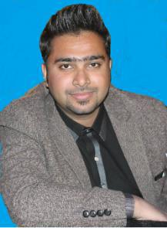

Mob # 03160155658

Email:zeeshan00021@gmail.com

OBJECTIVE:

Desire to join a reputed organization knock for striving to do the best. To get inspiration from seniors. Helping colleagues to maintain team work and work as a cohesive force.

PERSONAL INFORMATION:

Father’s Name | Muhammad Asif Khan
Date of Birth | 13-may-1993
Religion | Islam
Nationality | Pakistani
Marital Status | Unmarried

QUALIFICATION:

Matriculation
F.sc (Pre-Engineering)

Rawalpindi board Pakistan.

Rawalpindi board Pakistan.

BS (Software Engineering) Comsats University Islamabad.

Professional Skills:
- Freelancer

- SMM ( Social Media Marketing)

- WordPress Designer

- Seo ( Keyword research Specialist)

- Blog writing

- Youtube Seo Expert

Strengths:
- Patience.

- Confident.

- Optimist.

- Empathetic.

- Persistent.

Experience
- Consultant

CO-CURRICULAR ACTIVITIES:

- Seminars.

- You Tube Advertising.

- Workshops.

- Sports.

Reference Will be provided upon request.

