Chapter 3: Demonstrate how psychological studies are designed, conducted and reported in Psychology (36% of overall module mark)
You will analyse the data full data set collected by you and write up the study.
The write up of the experiment will comprise of the following sections:
- Title (not included in word count)
- Study Justification and Hypothesis (max 300 words - expected 100 words)
- A method consisting of the following sub-sections: Participants, Design, Materials, Procedure (Method and Results total max 400 words)
- Results (Method and Results total max 400 words)
- Discussion – ethics (max 400 words)
- Reference list (not included in word count) (APA 7th edition)
- Supporting materials (not included in word count)

Total overall word count is 900 words. Approximately 100 words on the justification, 400 on the method and results and 400 on the discussion

SEE attached file - ‘Study 1 Paper Smith et al’ for recruitment poster and study info.

SEE attached file - ‘Equation study – data labelled’.

Study data screenshot:
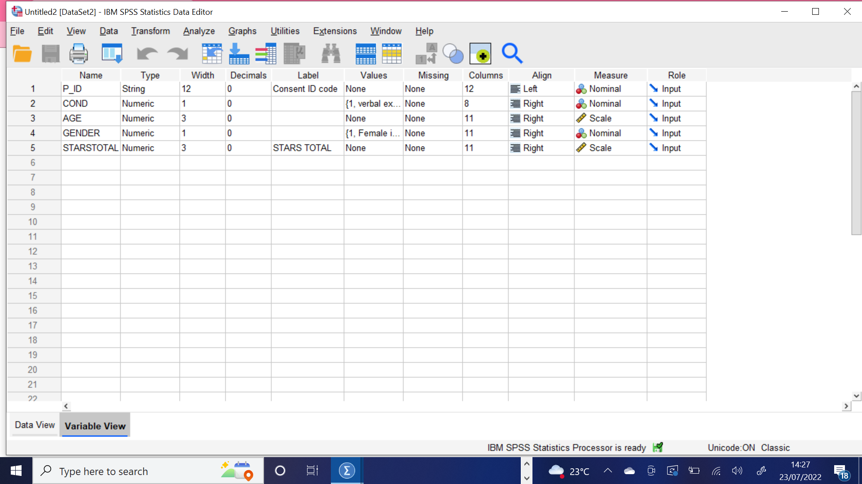

SEE attached file - ‘Descriptive Statistic ran’.

Screenshot of study data descriptive statistics ran:
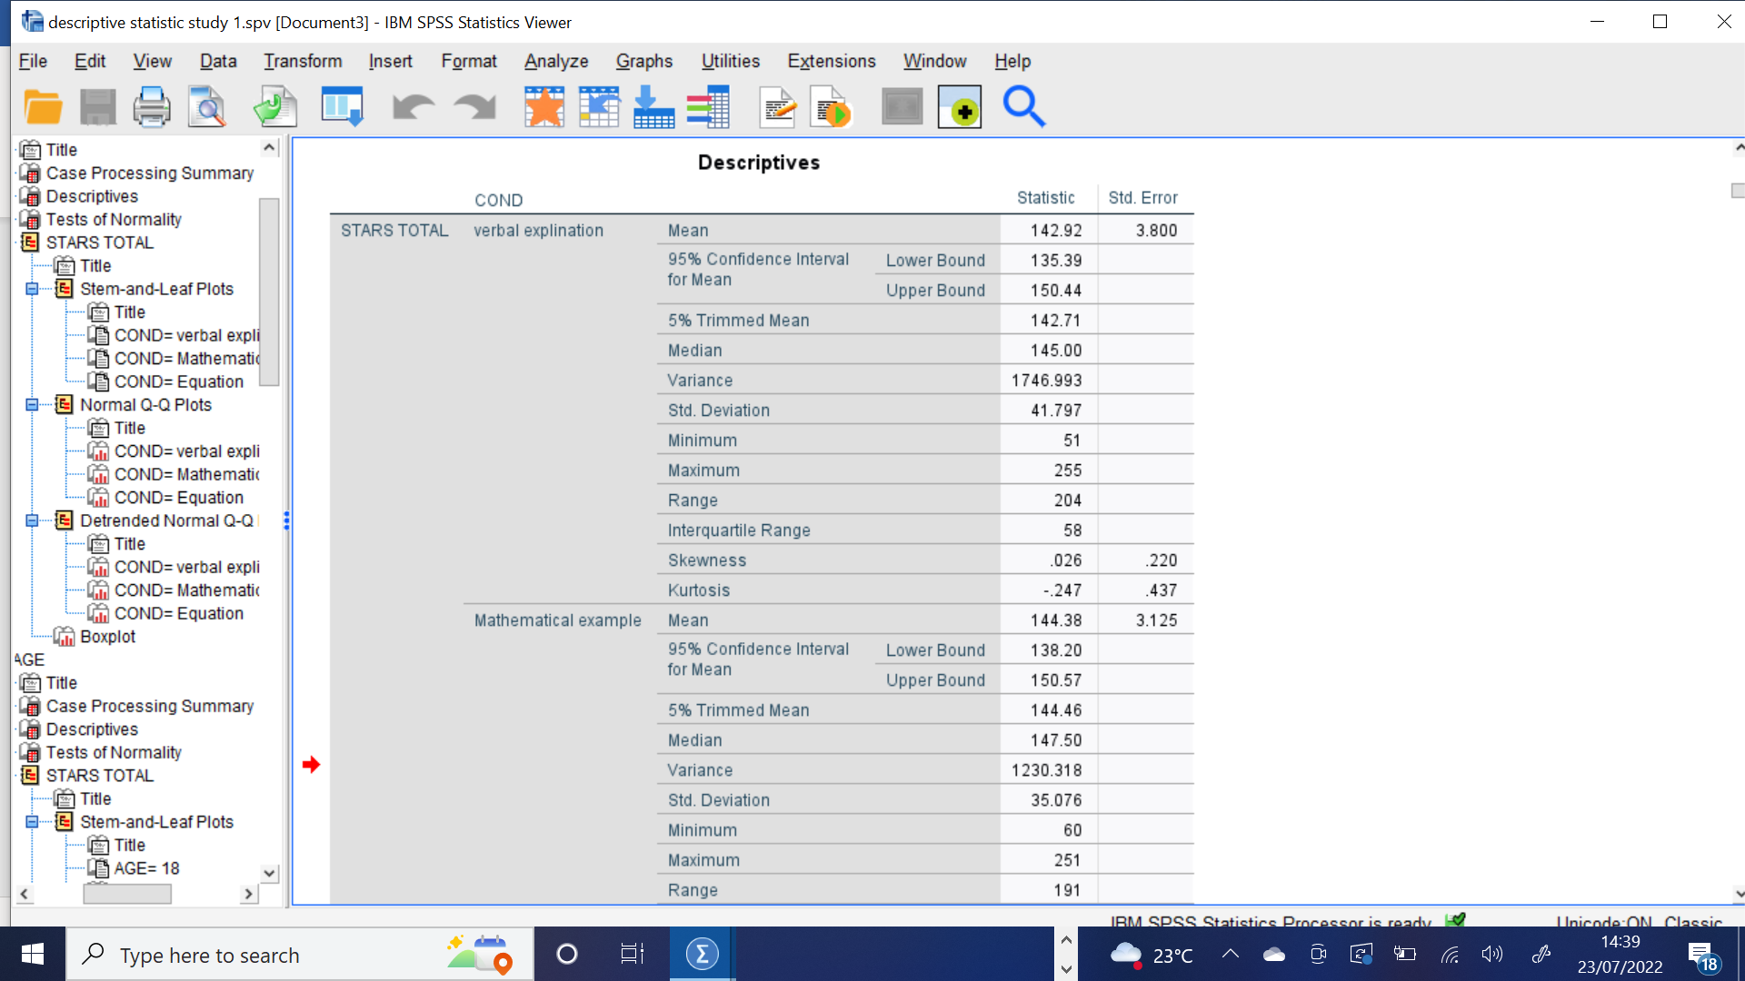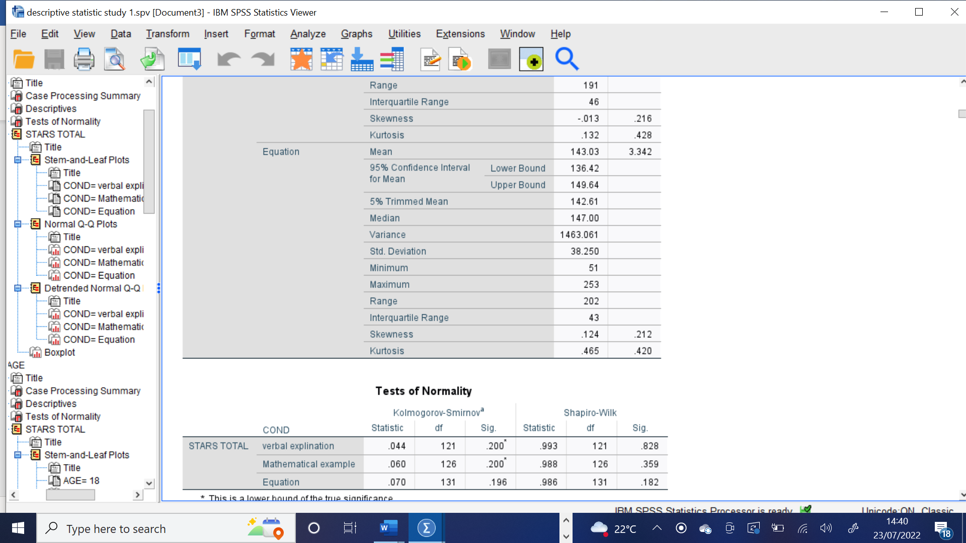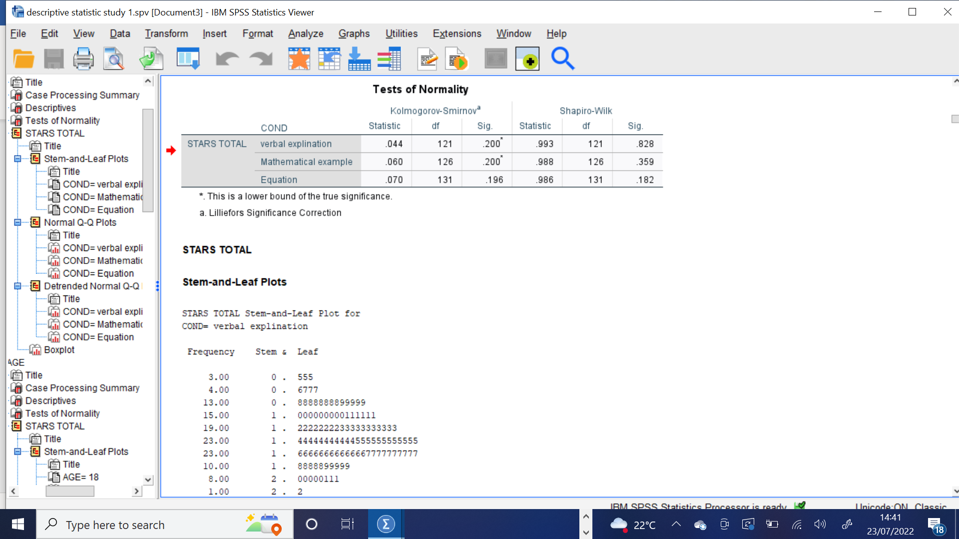

SEE attached file - ‘ANOVA ran’.

