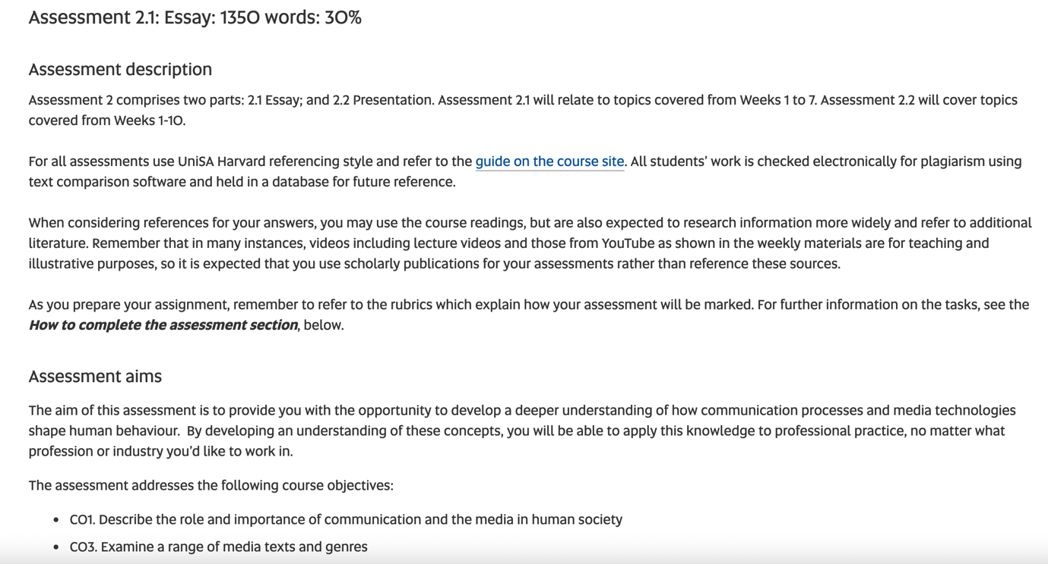

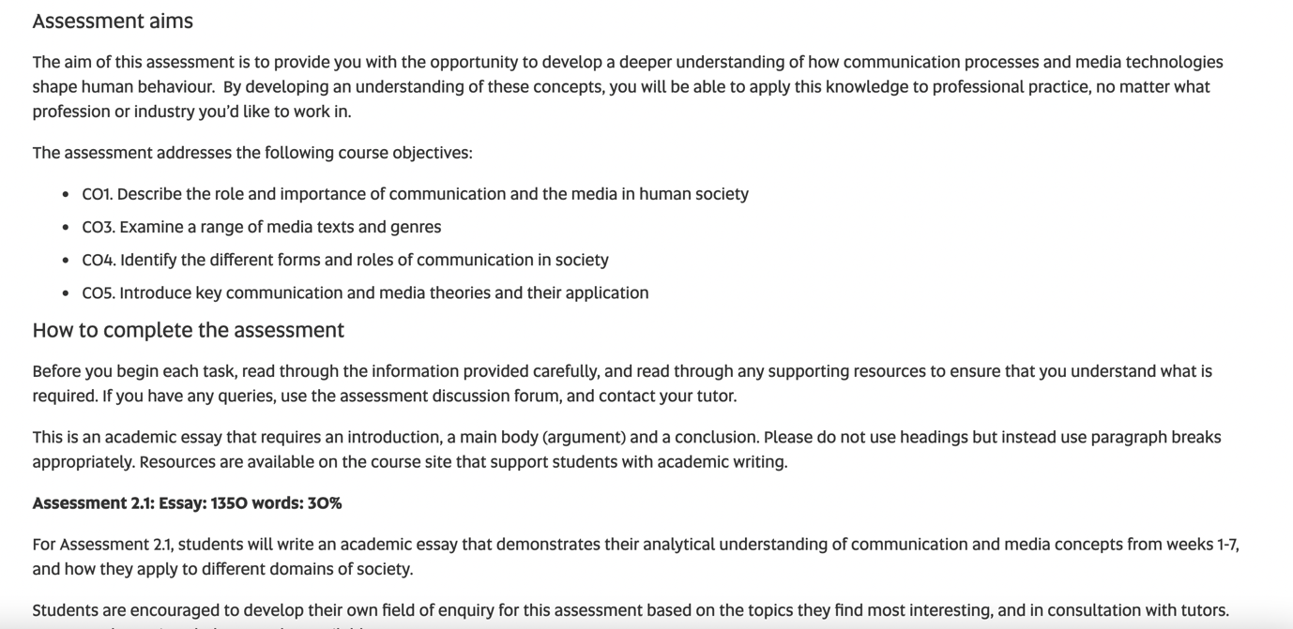

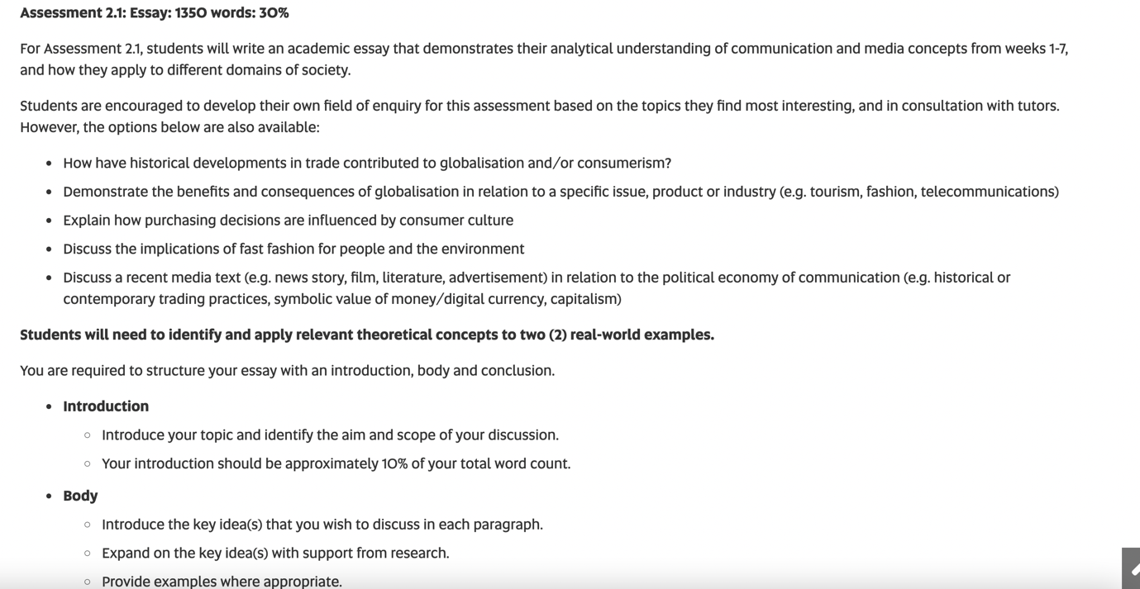

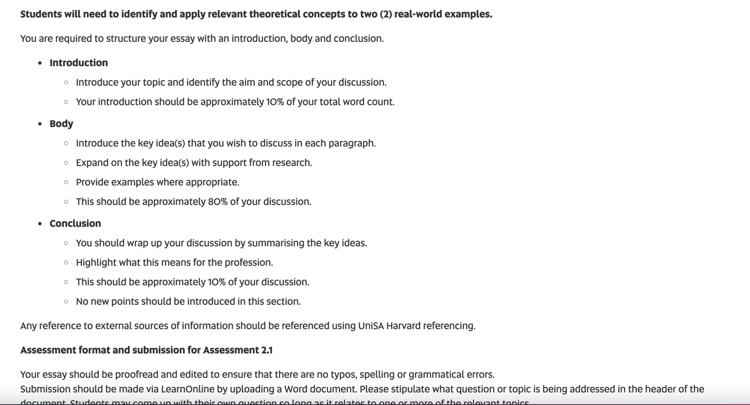

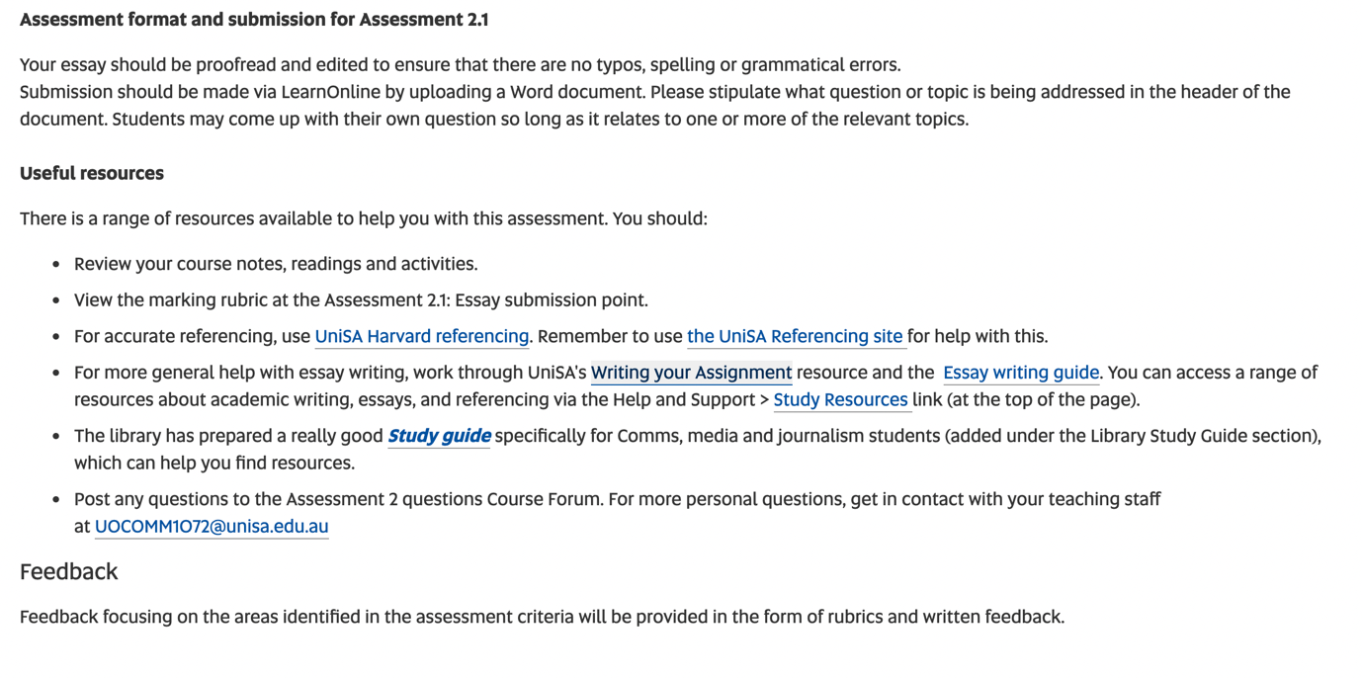

You may also want to watch this presentation by Fae to find out more about how to approach your essay, approx. 45 minutes. Please note this video is from a previous delivery of the course, where the assessment specifications were slightly different. However, we have kept this video up for you as you might find it valuable. You can also find the PPT slides from the video here.

https://www.youtube.com/watch?v=TTbkG3MnfVU&t=2s

