ECONOMIC DIPLOMACY:

POLICY RECOMMENDATIONS FOR PAKISTAN
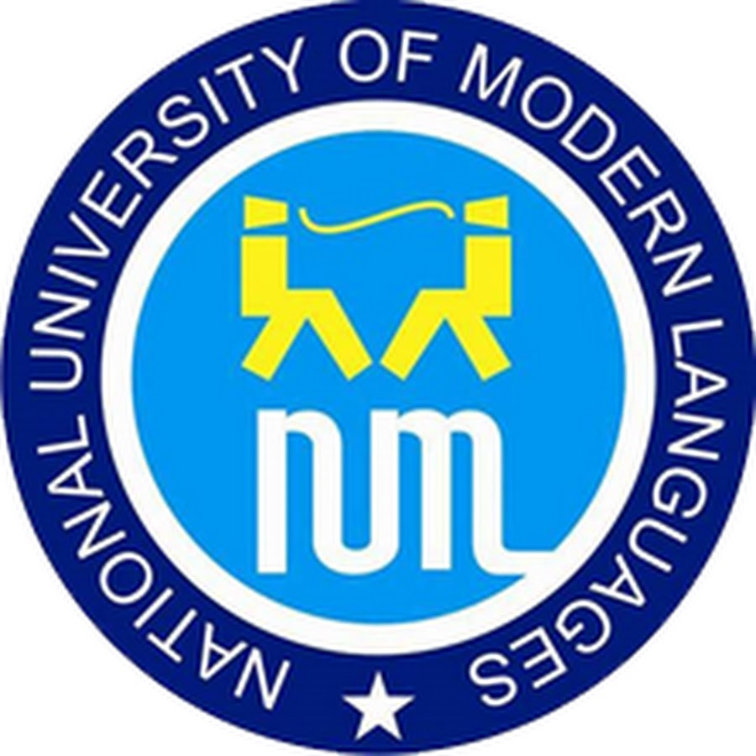

Submitted By:

Ahmed Hassan

Roll No. # 124

Course Name:

Economics and Finance for Policy Makers

MPhil Public Policy

Submitted to:

Sir Ahmed Bilal

TABLE OF CONTENTS:

International Relations in a Globalized World 3

Pp = (C+E+M) x (S+W) 4
Rise of the Trading State 6
Globalization 7

Economic Diplomacy 8

Pakistan’s traditional Foreign Policy Focus- Identifying gaps, threats and opportunities: . 10
Existential Threat/India centric policy 10

Dire need for forward looking State policy 12

Opportunities: 13

Case Studies: 15

China 15
Deng Xiaoping’s Economic Restructuring Plan 16

Source: GNU Free Documentation 17
Turkey: 18

India 21

Recommendations: 23

“America has no permanent friends or enemies, only interests” 23
CLEAR DEFINITION OF THE VISION AND MISSION 24

CAPACITY BUILDING 25
Enhancing government Inter ministerial coordination: 25

Human resource training and development: 25

Interaction with the business community: 26
MARKET INTEGRATION AND TRADE 26

Institutions to increase business and goals abroad 26

Pushing for greater role in multilateral financial institutions 27
EXPANDING GLOBAL LINKS: 28

Engagement with the Pakistani diaspora 28

EXPANDING REGIONAL LINKS: 29

Economic Integration of the Region 29

Key Takeaways:……………………………………………………….………………………………… 33

International Relations in a Globalized World

In 1988 Paul Kennedy introduced the idea of ‘Imperial over stretch’ in his book ‘The Rise and Fall of Great Powers’. He opined that in the past the dominant powers succumbed as their global or regional aspirations outstrip national capacities.¹ According to this novel thesis America was on its way to an imminent decline, however almost three decades down the road this prediction has yet to substantially materialize.

According to some analysts one major element that has kept the United States strong, despite some political paralysis and security challenges, is a flexible economy. This economy has the strength to sort itself out time and again, cleaning us messes and rapidly reallocating resources with capable management and strong entrepreneurship.² It is also relevant that the greater intensity of competition in the American market, compared to its Western European or Japanese counterparts, continues to force firms to keep changing and innovating. American firms are world leaders in information technology and venture capital has been readily available to newer industries of fuel cells, genetics and medical technologies.³ A dynamic and progressive economic environment has thus sustained and strengthened America’s political existence.

The power of Economic strength has long been considered an essential component in any form of political strength and stability. In theoretical literature among the more widely recognized indexes of national power is Ray Cline’s world power assessment index⁴. This multivariable, non-

- Traub, James. "Imperial Understretch and the Fall of Great Powers." Foreign Policy Imperial Understretch and the Fall of Great Powers Comments. N.p., n.d. Web. 18 Mar. 2016. <http://foreignpolicy.com/2013/10/18/imperial-understretch-and-the-fall-of-great-powers/>.

- "Imperial Overstretch?" The Economist. The Economist Newspaper, 29 June 2002. Web. 19 Mar. 2016. <http://www.economist.com/node/1188741>.
- Ibid

- "Reviewing Traditional Approaches to Measuring National Power." (n.d.): n. pag. Rand.org. Web.

linear index attempted to integrate both capabilities and commitment in nations contributing to an assessment of national power as follows:

Pp = (C+E+M) x (S+W)

Where:

Pp = perceived power

C = critical mass= (population + territory)

E = economic capability

M = military capability

S = strategic purpose

W = will to pursue national strategy

The Economic capacity component of the formula has a significant impact on perceived power assessments and includes income, energy, nonfuel minerals, manufacturing, food as well as trade. This formula was widely popular and was even employed by the US defense forces in the development of estimates of long-term trends in the international system. ⁵ Economic strategic planning thus is widely recognized as an essential component of power in a global context.

A 2014 book ‘Power Rules’ categorizes Pakistan as a Mid Level State in a Global power pyramid. This is justified by our substantial military strength for self defense, nuclear assets and strategic location for regional influence. However Gelb identifies our economic capacity as severely lacking.⁶ The following diagram stylizes her classification of global states and actors in

- Ibid

- Gelb, Leslie H. Power Rules: How Common Sense Can Rescue American Foreign Policy. New York: Harper, 2009. Print.

relevance to their power in the international food chain. If Pakistan wants to secure its position in the global power order, we immediately need to address our lacking capability in the realm of economic strength and international trade.


USA


8 Principals:

China, Japan, India,
Russia, UK, France,
Germany & Brazil


Oil Producing States: Saudi
Arabia, Iran, smaller Gulf
States, Venezuela, Nigeria


Mid Level States-

localised potential as Regional Players:
Pakistan, Mexico, Nigeria, South Africa,
South Korea, Taiwan


Responsibles- 50+ states:

Switzerland, Norway, Singapore, Botswana, Chile
etc.

Bottom Dwellers/Problem States- 75 states:

Afghanistan, Bosnia, Bangladesh, Indonesia, Burma,
Zimbabwe, Sudan, Chad, DR Congo, Uzbekistan etc.


Non State Actors:

NGOs, International Media, International businesses and
Terrorists

Rise of the Trading State

Harvard professor Richard Rosecrance ⁷in his 1986 book titled, ‘The Rise of the Trading State’, stated that in the global spectrum there are two kinds of states:

- Territorial States

- Trading States.

The territorial states are described as the ones with a focus on protecting and expanding territories and ultimate military might, while the trading states are more ‘liberal’ with their focus on economic exchange to balance power and initiate peace. In essence in todays global world sustainable progress can only be attained by actively pursuing trade in the international economy.

Along similar lines Joseph Nye in his book “The Future of Power”⁸ emphasizes how in today’s global interdependence ‘Smart power’ is the way forward. Though his focus is largely on the shifting trends of American global influence, the argumentation developed is relevant for a forward-looking state policy at all levels. Wielding power in the global information age has evolved from the conventional wisdom of military might to the exercise of ‘Smart Power’ i.e. the ability to combine hard and soft power into effective strategies in varying contexts.

"Smart power" in Joseph Nye’s own words is a term developed “to counter the misperception that soft power alone can produce effective foreign policy. Power is one's ability to affect the behavior of others to get what one wants. There are three basic ways to do this: coercion, payment, and attraction. Hard power is the use of coercion and payment. Soft power is the ability

- Rosecrance, Richard N. The Rise of the Trading State: Commerce and Conquest in the Modern World. New York: Basic, 1986. Print.

- Nye, Joseph S. "The Future of Power." Google Books. N.p., n.d. Web. 19 Mar. 2016. <https://books.google.com.pk/books?id=AH08y1Bi1Y0C&printsec=frontcover&source=gbs_ge_summary_r&cad=0#v=onepage &q&f=false>.

to obtain preferred outcomes through attraction. If a state can set the agenda for others or shape their preferences, it can save a lot on carrots and sticks. But rarely can it totally replace either. Thus the need for smart strategies that combine the tools of both hard and soft power”.⁹

A state thus has many strategic tools to employ smart power and Economic power is a major and more accessible component of strategic power projection. For more then a decade now economic power has been multipolar in nature with the United States, Europe, Japan and China being major players. Other nations such as the BRICS have also been gaining importance with much broader potential that can be tapped into by all states regardless of their size.

Globalization

Globalization, despite being a vague and challenging concept, is a reality of today’s world. There are many debates on weather globalization effects all countries equally. In one paper Sosa points out that the existing social inequality and unfair distribution of the benefits provided by globalization have shed some light on its damaging potential for developing economies as well where the world's rich and poor are more unequal primarily through neoliberal free trade policies. She further opines that globalization allows industrialized countries to expand their large markets through the implementation of free-trade zones, border areas where restrictions such as import tariffs have been reduced or eliminated. ¹⁰ These may stifle the weak industry with in creating skewed market forces detrimental for local economies.

- Nye, Joseph S. "Get Smart." Foreign Affairs. N.p., 02 July 2009. Web. 19 Mar. 2016. <https://www.foreignaffairs.com/articles/2009-07-01/get-smart>.

- Sosa, Karla. "Globalization and Economic Development in the Third World: Hazard or Enhancement?" (n.d.): n. pag. Web. <http://www.ia-forum.org/Files/JIXWRE.pdf>.

However trade is an essential part of long-term development and growth. It is a trend that cannot be avoided and it is imperative for the developing states to have an active diplomatic driving role in not only defining an economic direction but also actively assisting its development to fend against the negative aspects of globalization. To tap into the advantages of today’s global world while navigating clear of its potential pitfalls is essential for survival. It thus falls upon the state to take an active economic diplomatic role for sustainable progress.

Economic Diplomacy

Evolving from the traditional concept, Diplomacy is no longer confined to inter-state relations in an international system, but also involves the social, economic, cultural and political relations among networks of political actors in formal and informal domestic and systemic environments.

Lee, Donna and Brian Hocking ¹¹ opine that in essence the study of diplomacy has shifted from a focus on the diplomacy of economics in which the key theme was the economic tools of statecraft to the study of economic diplomacy in which two themes emerge:

- The diplomat as agent in International Relations (IR) and IPE

- How to fit non-state and non-foreign ministry officials into diplomatic agency.

Economic diplomacy is thus “the use of government relations and government influence to stimulate international trade and investment and covers a broad range of semi-permanent international representations (embassies, consulates and other public sector business

- Lee, Donna and Brian Hocking (2010) ‘Economic Diplomacy’ in Robert A. Denemark (ed.) The International Studies Encyclopedia, Vol. II, pp 1216-1227. Wiley Blackwell.

support facilities), domestic institutions (investment and export promotion offices), and diplomatic bilateral activities (trade and state visits)”¹².

Despite the advances made in communication and transportation technology, lower transportation cost and reductions in formal trade barriers, hurdles to international trade and foreign direct investment (FDI) remain large. This is mainly due to in formal trade barriers, cultural and institutional differences and modus operandus. Thus Economic diplomacy is increasingly recognized as “an instrument to deal with these intangible barriers to trade”.¹³

Despite critiques in literature Economic diplomacy continues to be a significant element for policy makers because of four main reasons¹⁴:

- Cultural factors may make it necessary for national governments to get involved in international transactions

- State enterprises may be the counterpart of a company operating in the international markets

- Political uncertainty about international transactions must often be removed or reduced. Government involvement may signal that a transaction will not raise political resistance.

- The information needed for international transactions sometimes requires involvement of government officials.

- Ibid

- Moons, Selwyn J.V., and Peter A.G. Van Bergeijk. "Economic Diplomacy Works: A Meta-analysis of Its Effect on International Economic Flows." MAER Colloquium 2013 (2013): n. pag. Web. <http://www.gre.ac.uk/__data/assets/pdf_file/0015/822102/Selwyn-J.V.-Moons-and-Peter-A.G.-van-Bergeijk-Economic-Diplomacy-Works-a-meta-analysis-of-its-effect-on-international-economic-flows.pdf>.

- Ibid

In this manner Economic diplomacy can serve as an essential policy tool to deal with certain market failures caused by restricted access to information, transparency and trust element between trading entities, thus lowering transaction cost of trade caused my information asymmetries.¹⁵

Pakistan’s traditional Foreign Policy Focus- Identifying gaps,

threats and opportunities:

Existential Threat/India centric policy

Since its inception, an existential crisis has dominated our state policies. With the dominant influence of a ‘garrison state’¹⁶ psyche, (A state which relies heavily on its fortification and military prowess to ward off internal and external threats) foreign policy has largely been dominated by security centric policies.

Robert LaPorte, Jr. borrows Laswell’s original definitions of Garrison state and applies the concept to Pakistan.¹⁷ Cohen further discusses this phenomenon in light of the view that the partition was instrumental in creating an inherent mistrust towards India in the military mind that compounded a garrison mindset¹⁸ that drove our state centric policies.

- Ibid

- Ahmed, Ishtiaq. "Pakistan's Garrison State Legacy." Pakistan's Garrison State Legacy. N.p., n.d. Web. 3 Dec. 2012.

**Ishtiaq Ahmed offers a definition: “A garrison state is one which relies heavily on its fortification and military prowess to ward off internal and external threats”.

- Jr, Robert LaPorte. "Succession in Pakistan: Continuity and Change in a Garrison State." Asian Survey 9 (Nov., 1969): 842-61. <http://URL: http://www.jstor.org/stable/2642228>.

¹⁸Cohen, Stephen P. The Pakistan Army: With a New Foreword and Epilogue. Karachi: Oxford UP, 1998. Print. pg 60

Along with a hostile attitude towards India, Pakistan had to face a dispute over the Durand line that it shared with its western neighbor Afghanistan¹⁹. The demand for ‘Pushtunistan’²⁰ was yet another thorn in the side of the new state. The Russian threat added another dimension to the Hobbesian conservatism of the state. Further more Pakistan’s relations with Iran also deteriorated in the 90s due to circumstances in Afghanistan, sectarian tensions in Pakistan and India Iran relations.²¹

All these factors over the years have contributed towards establishing and sustaining a ‘Garrison State’ status for the nation, which has been reflective in our policies. However the concept of smart power calls for an essential realignment of policies. Even at a basic level the demographic challenge of providing economic opportunities for the bulge of young population requires immediate attention, lest this huge resource falls back on shadow economies and illicit mercenary activities that already plague our domestic security. According to some figures an economic growth of 8% per annum is required for the effective absorption of this population bulge²². According to the economic Survey of Pakistan 2014-15 our GDP growth rate for the year improved to 4.24%²³, however this still falls far below the required 8% per annum. In this regard economic diplomacy, as a tool of accelerating our domestic markets, is not at the expense of our strategic security policy, rather it is an essential gap that undermines our security strategy and needs to be addressed urgently.

- Afghanistan was the only nation that opposed Pakistan's acceptance in the United Nations in 1948 because of this dispute. ²⁰Moore, Raymond A. Nation Building and the Pakistan Army, 1947-1969. Lahore: Aziz, 1979. 26. Print. pg 53

- Montazeran, Ahmed, and Kashif Mumtaz. "Iran-Pakistan: cooperation for regional stability and peace." <http://www.issi.org.pk/journal/2004_files/no_1/article/3a.htm>.

- "Towards Growth Strategy & Economic Reform." (n.d.): n. pag. Planning Comission of Pakistan. Web. <http://www.pc.gov.pk/feg/PDFs/growth_strategy-12Nov10_edited3.pdf>.

- "Growth and Investment." (n.d.): n. pag. Ministry of Finance- Government of Pakistan. Web. <http://www.finance.gov.pk/survey/chapters_15/01_Growth.pdf>.

24

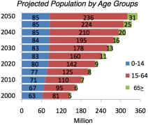

Dire need for forward looking State policy

Historically economic planning has been carried out on an adhoc basis with sketchy implementation of the limited policy directive that did exist. Lack of farsighted policies and sluggish movements of the agencies responsible (starting with inefficient execution of the first 5 year plan)²⁵ continue to plague us as a nation still.

Sporadic planning and sluggish implementation has resulted in a lack of coherence and depth in policy, which is largely still focused on firefighting and quick fixes. Furthermore political apathy and regional and limited loyalties have resulted in lack of commitment to and continuity of policies across regimes. Another exacerbating factor has been the lack of alignment in different policy dimensions, ill-defined institutional agendas, overlapping jurisdictions, communication gaps and lack of coordination. Lack of elite vision and commitment to broader synergized goals,

- Ibid

- Power, John H. "Development Strategy for Pakistan." (n.d.): n. pag. Pide.org.pk. Web. 19 Mar. 2016.

widespread corruption and institutional sluggishness has resulted in a demotivated nation. According to some reports corruption robs Rs22bn from Pakistanis every day.²⁶

According to Amartya Sen markets succeed only when public authority takes simultaneous steps to expand social opportunities. Therefore if a government is corrupt or inefficient then it is imperative that it be made reasonably honest and operationally efficient.²⁷ However we need to do much more then fix the ills of the past. It is imperative for our national strategies and foreign policy to evolve and align in order to keep up with the rapidly changing world and tap into its global potential. Economic diplomacy is a vital tool in this realignment.

Opportunities:

Joseph Nye identifies how in 1750, Asia had more than half of the world population and product. However by 1900, after the industrial Revolution in Europe and America, Asia’s share shrank to one-fifth of the world product. It is now being projected that by 2050, Asia will be well on its way back to its historical share.²⁸ Kishore Mahbubani offers a similar optimism regarding a shift in power towards the East in his book “New Asian Hemisphere: the Irresistible shift of Global Power to the East”²⁹. The author identifies how Asians have finally ‘understood, absorbed, and implemented Western best practices in many areas’. These include free-market economics and

- "Corruption Robs Rs22bn from Pakistanis Every Day." Pakistan Today. N.p., 25 Mar. 2016. Web. 20 Apr. 2016. <http://www.pakistantoday.com.pk/2016/03/25/business/corruption-robs-rs22bn-from-pakistanis-every-day/>.

- Naqvi, Nawab. "Pakistan Economy: Continuity or Change." Institute of Policy Studies Islamabad, n.d. Web. 19 Mar. 2016. <http://www.ips.org.pk/economy/1107-pakistan-economy-continuity-or-change>.

- Nye, Joseph S. "The Future of Power." Google Books. N.p., n.d. Web. 19 Mar. 2016. <https://books.google.com.pk/books?id=AH08y1Bi1Y0C&printsec=frontcover&source=gbs_ge_summary_r&cad=0#v=onepage &q&f=false>.

- Mahbubani, Kishore. "New Asian Hemisphere: The Irresistible Shift of Global Power to the East." N.p., n.d. Web. 19 Mar. 2016. <http://www.mahbubani.net/book3.html>.

modern science and technology. According to him Asians have become innovative in their own way, creating new patterns of cooperation not seen in the West³⁰, and thus stand poised for a takeoff in this century. As a nation we need to align our policies in order to take advantage of this predicted shift.

There have been some positive steps taken by government in the recent past, which will render positive outcomes for the economic growth. The European Union (EU) granted GSP Plus status to Pakistan in 2014.³¹ United Nations acknowledged “Pakistan's Instrument of Accession to the Customs Convention on the International Transport of Goods (TIR Convention) which will significantly encourage Pakistan's exchange of goods with Afghanistan, Central Asian and ECO nations.”³²

Our Geo strategic location links India with Iran, Afghanistan and Central Asia, provides access to the sea for land locked central Asian states, Afghanistan and western China, acts as the energy and transit corridor and opens up to the oil rich Gulf States next door offers great advantages. It gives us significant edge in the employment of Diplomatic economic tools to our advantage.

Pakistan has been listed in the NEXT 11, an identification of the next 11 economies that could potentially have a BRIC like effect in rivaling the G7.³³ There is immense raw potential to be tapped and we need to align our policies with a forward-looking stance in order to do so. In this

- Ibid
³¹"EU Grants GSP Plus Status to Pakistan." DAWN. N.p., 12 Dec. 2013. Web. 19 Mar. 2016.
<http://www.dawn.com/news/1072051>.

³²"TIR Convention to Facilitate Pakistan." DAWN. N.p., 11 Aug. 2015. Web. 19 Mar. 2016.
<http://www.dawn.com/news/1199708>.

- "The N-11: More Than an Acronym." (n.d.): n. pag. Goldman Sachs. Mar. 2007. Web. 19 Mar. 2016.

case it would be worthwhile to look into and learn some lessons from other regional economies that tapped into the benefits of economic diplomacy.

Case Studies

China

China became the largest economy in the world based on Purchasing Power Parity exceeding US $18 trillion in 2014 as per the estimates of the World Bank. The Chinese community owns a fifth of the world’s GDP and has over US $4 trillion of foreign exchange reserves.³⁴ The country however wasn’t at this position prior until the 1980s. In 1980, China was ranked 32nd in the world trading community with a per capita income of US $250. Shift in the overall economic policy of the country has turned things around. Today, just 11.18% of the total population lives under the poverty line of US $1.90 per day. The country is now the largest trading partner of over 140 countries.³⁵

The Chinese economy has seen two different periods over the course of the modern history:

- Socialist Centralized Planning Era (1949 – 1979)

- Deng Xiaoping’s Economic Restructuring Plan

Policies of these two different eras were tailored to the needs of the time, the vision of the Communist Party of China, how the global economy was working and need to be studied in detail to see how they shaped the economy of the country.

- World Development Indicators Database. World bank 2017.

- ibid

Deng Xiaoping’s Economic Restructuring Plan

Deng Xiapong was the ‘paramount leader’ of China from 1978 until 1992. He never held the office as the General Secretary of the Communist Party, head of the government or the head of the state but he led his country through market-economy reforms. The new changes introduced permeated all aspects of Chinese life, society, economy, politics, defense and diplomacy.

The 11th Central Committee of the CCP held its 3rd Plenary Session in December 1978 and embraced Deng’s outline for modernization of the Chinese economy and the economic reforms.³⁶ This meeting was the turning point in the social and economic development of the country. It was decided at this meeting the framework and strategies for economic administration in the country would be changed; economic co-operation with different nations would be extended; special endeavors would be made to receive the modern technologies and hardware; and that educational and scientific work would be extraordinarily fortified to address the issues of modernization. The significance of the four modernizations (modernizing industry, agriculture, science and technology, national defense) was accentuated.³⁷

The Communist Party of China decided to focus on “rapid growth in production [to] improve the people’s living standards significantly and strengthen national defense”³⁸ Emphasis was made on efficient economic management and relevance of professionalism. Moreover, efforts were made to promote competent and talented people. Economic Incentives were incorporated in the system. It was decided that the reforms should start with agriculture since national economy was based on this sector. Special consideration was given to the rule of law, decentralization and

- Tisdell, C. 2008. Thirty Years of Economic Reform and Openness in China: Retrospect and Prospect. The University of Queensland, Brisbane, Australia. October, 2008.
- ibid

- The Research Department of Party Literature, Central Committee of the Communist Party of China (1991) Major Documents of the People’s Republic of China – Selected Important Documents since the Third Plenary Session of the Eleventh Central Committee of the Communist Party of China (December 1978 and November 1989). Foreign Languages Press, Beijing.

the ownership in making the reforms. These components were applied to other sectors of the economy later. On the political level the main initiatives included establishment of rule of law, freedom, grant of basic individual rights, and investment in higher education, united front, and mobilization of overseas Chinese etc.³⁹ Simultaneously with their ‘Economic Reforms’, Deng Xiaoping and his team unleashed ‘Soft power revolution’ by releasing the energy of the private entrepreneurship, ensuring full participation of women in economy and society; mindset change through education and mass media.⁴⁰

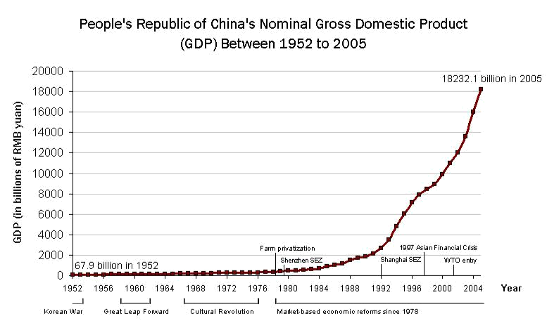

Source: GNU Free Documentation

This graph shows the economic growth after the adoption of Deng’s policy and this indicates the growth in the GDP of the country after 1978.

- ibid

- Lai, H. & Lu, H. 2012. China's Soft Power and International Relations.

The key factors contributing to Chinese miracle was centered on Deng’s Reforms and Open door policy where China’s foreign policy was based on ‘Thousand Friends, Zero Enemies’ where country avoided conflicts and disputes to boost the economy and trade. Relations with the neighboring countries were improved, normalization of relations with Western countries and other Asian nations such as Japan had a great impact on the economy of China.⁴¹

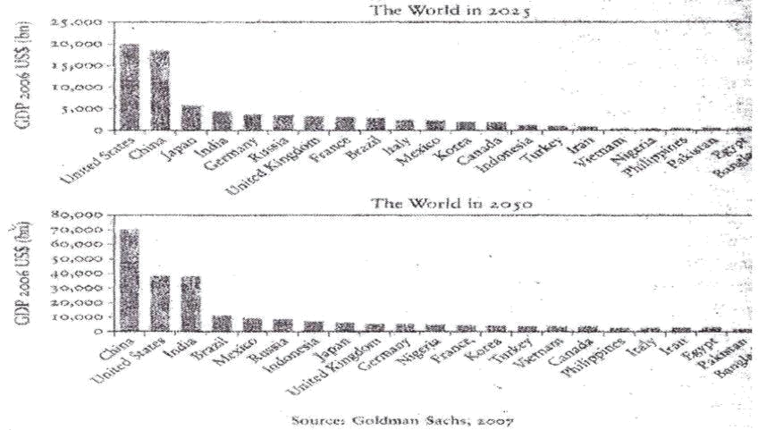

According to the projection of Goldman Sachs, GDP of China will match the GDP of United States by 2027 and gradually pull ahead. It will almost double by 2050.⁴²

Turkey:

Like most other countries, at the time of its creation, Turkey’s priorities revolved around managing tensions with its neighbors and stabilizing internal conflicts. Until 1990s, Turkey’s

- Ambassador (Retd) Syed Hasan Javed. China Development Experience. 2016. A lecture in NUST.

- Kupchan, C. 2012. The World in 2050: When the 5 Largest Economies Are the BRICs and Us. The Atlantic. Feb 17, 2012.

foreign policy was inclined more towards the use of military power in order to maintain a strong position in the region. Inclination towards steering the foreign policy of turkey towards economic diplomacy began around 1983, the efforts increased in the wake of the isolation that Turkey was about to suffer through its territorial conflicts.

In the 1980’s under the leadership of Turgut Ozal, Turkey aimed to achieve interdependence among the countries in the region and attempted to resolve the conflicts with them⁴³. Through this, Turkey could improve its political standing and to achieve that it reached out to the world by opening up its own economy. Trade liberalization policies were introduced in the 1980’s which promoted Turkish products in the world. One of the most important changes that it brought about was the evolution of the structure of the economy. Earlier an agriculture based economy, a large manufacturing structure emerged in Turkey. Services, sector especially banking, health, tourism and communication, began to thrive. The attempt to liberalize, hence, was futuristic in itself as it triggered the economy to reform itself to bring out its strengths in these sectors, unexploited before. Turkey’s economy grew from $46 billion in 1975 to $742 billion in 2008 making it the 18th largest economy in the world. The total number of third-country nationals entering Turkey increased from just over 1 million in 1980 to around 25.5 million in 2009. This reinforces the idea of interdependence: Turkey not only strengthened its industries to serve the entire region, it also provided employment to a large number of people.

According to Krisci, the inspiration for the incline towards geo-economics possibly came from the European Union. Literature suggests that the increased interaction with the EU prompted Turkey to seek harmony with it by putting an effort to make its stern foreign policy milder if not completely benign. Other social scientists suggest that the realization to connect with the neighboring

⁴³ Major issues such as Greek-Turkish relations, the Arab-Israeli conflict after the Gulf crisis

countries is rooted in Turkey’s ideological existentialism. Domestic politics also plays a vital role in the tilt of Turkey’s foreign policy. A plausible explanation of Turkey’s pursuance of economic diplomacy, then, can be said to be a combination of all of these factors. Apart from these, indirect factors such as the Iran-Iraq war gave a boost to the newly established industry, strengthening its place in the region.

As a part of his strategy of inviting foreign investment, Ozal worked hard to relax visa requirements to enter Turkey, to allow a greater movement of people across borders as a mechanism for peace-building, but also for trade and interdependence. Today travel and tourism sectors generate 12 percent of Turkey’s GDP.⁴⁴

Turkey has developed a very well balanced palette of goods and services for import. Its construction industry, retail stores and manufacturing industry including electronics, glassware and confectionery etc., are all making a mark in the international market⁴⁵. Turkish universities and scholarship programmes attract students from all over the world, to strengthen the education economy as well as promote cultural exchanges. Especially preferred are cultural studies and contemporary studies programmes. ⁴⁶

Turkey had more than its fair share of territorial issues during the 1990’s as well and the ideology of interdependence got severed due to it, however, by 2000 a visible shift could be seen in the foreign policy, in its inclination towards economic diplomacy, again. Turkey has set a unique example of handling geopolitics and geo-economics side by side Krisci writes, “The extent of the transformation of Turkish foreign policy and the accompanying attitudes towards Turkey is

- Hurriyet Daily News, 2015, Travel, tourism sectors generater 12 pc of Turkey’s GDP: Report, May 28,

- Kirişçi, K. and Kaptanoğlu, N., 2011. The politics of trade and Turkish foreign policy. Middle Eastern Studies, 47(5), pp.705-724,

- Pultar, G. and Kırtunç, A.L., 2010. Cultural studies in Turkey: Education and practice. The Review of Education, Pedagogy, and Cultural Studies.

probably best captured by the standing ovation that the then Minister of Foreign Affairs Abdullah Gül received at the OIC meeting … in Tehran in late May of 2003.” (Krisci, 2011)

India

India is the economy which, not just the region, but the entire world has its eyes on. In February 2016, Frobes magazine predicted that India will be the world’s largest economy in x years if it continues to grow at the current rates. At 7.5%, India’s economic growth rate surpassed China’s (6.9%) in 2015⁴⁷. The early years of India’s independence were marked with conflict with its neighbors especially Pakistan and China. India was seen as a nuisance in the region, even causing concern to the United States due to its socialist tendencies and relations with the USSR. Today however, there is hardly any country in the world which does not seek to improve relations with India. A closed, semi socialist economy, India’s working conditions were bad; the manufacturing industry was producing average products and the agricultural economy did not attract much attention either. Conditions for foreign entrants were rigid and there was the rule of licensing and quota systems.

In 1991, with the economy at a perilous point of almost going bankrupt, Finance Minister Dr. Manmohan Singh introduced trade liberalization, abolished quotas and eased licensing. Foreign investors saw this as a good opportunity to invest in the region and started functions in India. Although reform in the industrial sector in the 1980’s played an important role to spur growth, the changes introduced in the 1990’s were more systematic and systemic.

One distinct feature of Indian economy is the liberalization of the services sector which is traditionally is under rigid control of the government and public enterprises have monopoly in

- BBC. 2015. India outpaces China in 2015 economic growth.

most countries. This has allowed India to make a strong mark in the service industry in the world. Foreign investment not only brings in revenue but it also makes the local enterprises more competitive. The telecommunication and consequently the information technology greatly benefitted from this. Similarly, the infrastructure sector is also open to foreign direct investment with easy entry requirements into the market.

The strategy of opening up the market was initially to strengthen the economy and economic diplomacy ultimately followed. By allowing large foreign investment, India ultimately held stakes of countries all over the world and became a marketplace of choice. As a result, the diplomatic ties become very strong. In this case, timing also played a vital role, as India was the first country in the region that held a very large proportion of the world’s population, to allow such a large extent of foreign investment.

Apart from strengthening the traditional sectors of economy to reach out to the world, perhaps the most forward looking policies of India are the extensively well planned branding campaigns. Tourism, technology and media related outreach programs present India in a favorable light to the people around the world allowing it to use the attention to its geostrategic advantage. The increased influence of India fares well for the politics as well as the economy. The ‘Incredible India’ tourism marketing campaign launched in 2002 is an example of a remarkably effective venture. The number of tourists to India surged and the image of India as a country rich in unique culture was reinforced.⁴⁸ The Bollywood, India’s film industry, is also playing a remarkable role in showing the kind of image of India to the world that it wants to see. The ugly truths like poverty and corruption are glossed over and the image of India as a growing economy is the only side

- Singh, S., & Turan, M. 2006. Indian Tourism In The Paradigm Of Incredible India Campaign. Journal of Hospitality Application & Research, BIT Mesra, Ranchi

shown to the world. The strength of the media industry can be observed by the fact that in 2013, Bollywood had a 0.5% share in India’s GDP which is fairly large⁴⁹. Through this smart approach India has altered the way the world looks at it which will have long term positive effects.

India is leading the information technology industry by training its human resource- a resource that India has in excess- well enough to be traded with the world. Indian Diaspora dominates the IT industry all over the globe. The government recognizes this as an opportunity and uses it to form business to government linkages. These kinds of linkages are very relevant today as corporations are becoming more and more powerful.

Due to India’s geostrategic location, India has worked economic diplomacy very well. Other than China the region mostly has small, developing countries. Since India has developed a strong economy, countries like Nepal, Sri Lanka and Bangladesh have become dependent on it for support which it offers them to maintain its influence. India has developed infrastructure in these countries and is also their largest trading partner. This makes India a political power in the region as well.

Recommendations:

“America has no permanent friends or enemies, only interests” Henry Kissinger⁵⁰

This statement implies that a sound foreign policy is flexible and opportunistic in nature. Pakistan may have lagged behind in developing economic diplomacy but there are still massive

- India Times. 2014. Media Industry Contributes 0.5% To GDP.

- “America Has No Permanent Friends or Enemies, Only Interests”. Goodreads. N.p., n.d. Web. 19 Feb. 2014.

opportunities and potential for it to catch up. According to Goldman Sachs, Pakistan ‘presents interesting growth stories’ and has the economic potential to be a rival to the G7 countries. ⁵¹

CLEAR DEFINITION OF THE VISION AND MISSION

The ultimate mission and the corresponding vision for Pakistan have been constructed as a part of the vision 2025, launched in 2014. The Vision 2025 has different pillars, one of them is related to growth i.e. Growth: Sustained, indigenous, and inclusive growth which will prove to be vital for developing Pakistan’s economic diplomacy⁵². The response to this initiative from the public however has been lukewarm. A large portion of the population is either unaware of the Vision or do not understand the content. The Pakistani public including its educated class and media personnel are unaware of the significance of economic diplomacy for Pakistan⁵³. In contrast to this, India has had smart marketing strategies to promote its economy overall as well as individual programs tailored to promote specific sectors of the economy such as ‘Incredible India’, ‘Make in India’, and ‘Digital India’.

Pakistan’s government, Pakistan’s public and the rest of the world, in this sequence, should be made aware of Pakistan’s economic vision. Strong and independent mass media in Pakistan can play a vital role in communicating government vision to the public. The effect of this would be dedication of the overall population towards the greater goal.

- Goldmansachs. 2007. Beyond the BRICS: A look at the Next 11.

- Planning Commission. Pakistan Vision 2025.

- Aziz, M. 2015. Economic Diplomacy Matters. The News

CAPACITY BUILDING

Enhancing government Inter ministerial coordination:

Since economic diplomacy calls for different state and non-state actors working together, liaison between the government departments needs to be very strong and should be given the first priority. It is recommended that the office of the PM shall be responsible to oversee and coordinate between the Ministry of Commerce, Economic affairs division, and the Ministry of Foreign Affairs. An even better alternative would be to create a functional team, with members from both ministries and a team lead from either ministry for alternate periods. This team will be responsible for coming up with well researched reforms for economic diplomacy and for keeping up with the rapidly changing trends. Standard operating procedures aimed at ensuring good co-ordination may be introduced and implemented the resources available to all the ministries should be used collectively in order to ensure well-crafted and timely reforms. These resources may range from literature to data and human resource.

Human resource training and development:

The human resource working for the government especially serving the foreign missions needs to be given trainings regarding economic diplomacy and how to pursue it. It is important to note here that developed skills of an individual in a leadership position can dramatically improve economic diplomacy as they are able to negotiate and sign deals of an unlimited magnitude without having to depend on others to provide a roadmap. Hence, the trainings should, on priority, be aimed at senior level bureaucrats and then to the descending hierarchy. The academia can play a vital role in conducting these trainings. At present, the focus of the government officials is majorly on

security which indeed is important, but economic growth is as important in the long-run and we have to develop skilled workforce accordingly.

Interaction with the business community:

Turkey has benefitted a lot from integrating the government machinery with the private sector to enhance trade. In Pakistan, at present there is no coordination mechanism among government and private industry hence there is hardly any contribution of the private sector in policy making. This leads to policies that are inefficient as the private sector is a major stakeholder in the economy of the country. Not only this, it brings out a feeling of alienation in the private sector. On the rare occasions this stakeholder gets representation, it is usually biased towards a certain group of industrialists or trades which lacks knowledge and interest in providing a holistic view of things. Federation of Pakistan Chambers of Commerce and Industry should be consulted for bringing up fresh perspectives to the table. The FPCCI can prove to be a vital link between the government and private sectors.

MARKET INTEGRATION AND TRADE

Pakistani government has often failed to support Pakistan’s business interest in the foreign markets. The needs urgent rectification, here are some of the ways that can help us achieve that:

Institutions to increase business and goals abroad

Pakistani government and private organizations frequently have similar objectives; however there is lack of coordination between them. A more engaged exertion by the Pakistani government to make organizations that integrate Pakistani businesses with worldwide markets will advantage both Pakistani government and the businesses in the country. For instance, establishing an Economic Intelligence Unit (EIU) in the government, preferably within the Ministry of

Commerce or the Ministry of Finance could help the Pakistani government successfully monitor business advancements that influence Pakistan’s key objectives. Commercial Counselors of Pakistan on Pakistan’s Trade Missions abroad and the diplomatic missions shall work towards business advancements.

Moreover, making organizations such as National Offset Authority (NOA) that would empower Pakistan to draw a link between its main imports to leverage benefits in diverse areas will be useful. The NOA will allow Pakistan to adequately influence its position as one of the biggest importers of different goods to acknowledge more extensive advantages from specific import deals - preferably convincing trade partners to supply the technologies whose advantages are not confined to the a single sector alone. NOA shall work in alignment with Strategic Export Control Division of Ministry of Foreign Affairs to leverage benefits in diverse areas. We need to optimize the setting up of the aforementioned institutions NOA and EIU with the goal that Pakistan can adequately influence its business triumphs to gain broader strategic objectives.

Pushing for greater role in multilateral financial institutions

Pakistan hasn’t been a big player in the global economy, this has some serious implications. One of them is that Pakistan has failed to have an important role in important financial institutions. The country needs to build the network of its economic representative in international financial institutions.

Despite being one of the founding members of Asian Infrastructure Investment Bank (AIIB), Pakistan missed an opportunity to lead one of the key constituencies of the China led Bank in August, 2015.54 Pakistan needs to play an important role by having experts at key positions in multilateral financial institutions.

- Dawn. 2015. Pakistan misses chance to have a director on AIIB board

EXPANDING GLOBAL LINKS:

Pakistan’s economic relations with countries apart from its neighbor have been improved by the increase in trade and the assistance for development. Moreover, the diaspora of the nation is broadly distributed and widespread. For instance, Pakistan’s remittances were $18.4 billion in 2014-15⁵⁵, compared to the country’s FDI inflows of USD 709.3 million in 2014-5.⁵⁶ Hence, relations with the countries that host the Pakistani diaspora need delicate nurturing by implementing the right set of strategies.

Engagement with the Pakistani diaspora

The Pakistani diaspora offer numerous skills, knowledge and expertise for the development of the nation. Along with remittances, they help build Pakistan’s cloud in the foreign countries through priceless offerings to the societies and economies of the countries they are residing in. Apart from this clout, they also help in the FDI outflow of the country. Ministry of Overseas Pakistanis and Human Resource Development shall arrange new institutional connections to take advantage of the huge potential offered by human capital, and altruistic potentials of the Pakistani diaspora, the Government of Pakistan ought to encourage more prominent institutional commitment with the Pakistani diaspora. Pakistan ought to assign a foreign services officer at every mission to assist as a Diaspora Officer and organize outreach events at every Pakistani Embassy or High Commission in nations that have a vast Indian group.

Indian Prime Minister Narendar Modi has been a key proponent of engaging Indian Diaspora and this is a need of the modern time. He has addressed the global Indian Diaspora through video conferencing57 and has been involved in directly engaging with the Indian

- Alam, K. 2015. Pakistan pockets remittances amounting to $18.4b. The Tribune.

- World Bank. Pakistan’s FDI Inflow.

- 2013. Shri Modi addresses Indian Diaspora across US & Canada

community in his visits to different countries. In his recent visit to Malaysia in November 2015, he said, “India is not confined to its territory. India exists in every Indian in every part of the world.”58 A reporter recently commended Modi’s efforts and said, “Of all the world leaders who have visited Britain, only Nelson Mandela and the Pope have addressed bigger public gatherings than Narendra Modi's rally at Wembley.”59 This should be the approach of Pakistani leadership in order to engage the diaspora and increase global links.

EXPANDING REGIONAL LINKS:

Pakistan has a significantly large stake in the stability and growth of the region. The strategic location of Pakistan calls for strong bilateral relations to ensure prosperity in the country and the region.

Economic Integration of the Region

Pakistan shall mobilize the regional economic partners and move towards Economic Integration of the region. According to the UN Economic and Social Commission for Asia and the Pacific (2004)⁶⁰, there are five basic areas of regional integration illustrated in the figure below. It is imperative that all of them shall be dealt with to ensure regional integration. The figure presents inter-linkages of the regional co-operation in different sectors, illustrating graphically crucial spheres of integration and their direct or indirect influence on the growth in the region; it focuses on the economic and institutional stability.

- The Hindu. 2015. India not confined to its territory: Modi

- Whitehaead, A. 2015. Why Indians abroad succumb to 'Modimania'. BBC.

- Meeting the Challenges in an Era of Globalization by Strengthening Regional Development Cooperation, Economic and Social Commission for Asia and the Pacific, United Nations, New York, p. 26

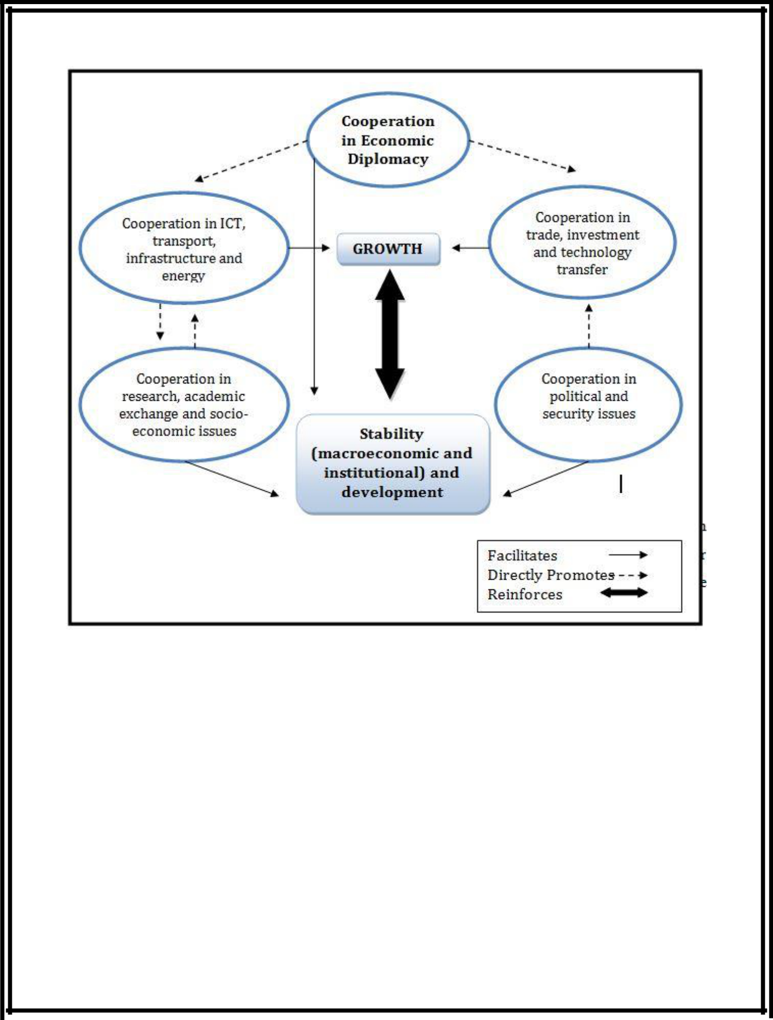

Source: UN Economic and Social Commission for Asia and the Pacific

The following problems should become the key focus: trade and investment, cooperation in economic diplomacy, managing of the regional public goods, cross-border infrastructure.⁶¹ These issues shall be of prime interest to the governments in a region to ensure regional integration which will be beneficial for all the states involved.

- Progress of Regional Cooperation and Integration in Asia and the Pacific. The Boao Forum for Asia and Asian Development Bank, Manila 2007

“Regional economic integration cannot be achieved without comprehensively addressing the politically instigated issues and infrastructural problems, both at country and regional level. The member states of SAARC are still far from their goal of regional economic integration. It is important to build a sound foundation without which the goal of South Asian Economic Union would only remain a dream.”⁶²

Key Takeaways:

Our Geo strategic location links India with Iran, Afghanistan and Central Asia, provides access to the sea for land locked central Asian states, Afghanistan and western China, acts as the energy and transit corridor and opens up to the oil rich Gulf States next door offers great advantages. It gives us significant edge in the employment of Diplomatic economic tools to our advantage.

Pakistan has been listed in the NEXT 11, an identification of the next 11 economies that could potentially have a BRIC like effect in rivaling the G7. There is immense raw potential to be tapped and we need to align our policies with a forward-looking stance in order to do so. In this case it would be worthwhile to look into and learn some lessons from other regional economies that tapped into the benefits of economic diplomacy.

It is about time we realize that we need to show ownership to the problems of the country and take proactive measures to turn things around. Pakistan’ policies and decision making on Economic Diplomacy (and trade and investment) are made when it is evident that a certain policy is completely ineffective i.e. we only make a new policy once we realize it is of no use. We need

- Pakistan observer, ‘Trade cooperation among SAARC member states urged’.

to ensure that our decisions are proactive rather than reactive and we are in constant search of ways

to enhance our trade and market integration.

Bibliography

Alam, K. Pakistan pockets remittances amounting to $18.4b. The Tribune. 2015.

Alipour, H. Tourism development within planning paradigms: the case of Turkey. Tourism Management, 17(5), pp.367-377. 1996.

Ambassador (Retd) Syed Hasan Javed. China Development Experience. 2016. A lecture in NUST.

Aziz, M. Economic Diplomacy Matters. The News. 2015.

Aziz, Majyd. "Need for Economic Diplomacy." The News. N.p., 7 Dec. 2015. Web. 19 Mar. 2016. <http://e.thenews.com.pk/newsmag/mag/detail_article.asp?id=6385&magId=10#sthash.z zrf48e9.dpuf>.

BBC. India outpaces China in 2015 economic growth. 2015.

Cohen, Stephen P. The Pakistan Army: With a New Foreword and Epilogue. Karachi: Oxford UP, 1998. Print. pg 60

Dawn. "Economic Diplomacy." DAWN. N.p., 18 Aug. 2015.

Dawn. "EU Grants GSP Plus Status to Pakistan." DAWN. N.p., 12 Dec. 2013. Web. 19 Mar. 2016.

<http://www.dawn.com/news/1072051>.

Dawn. "TIR Convention to Facilitate Pakistan." DAWN. 11 Aug. 2015. Web. 19 Mar. 2016.

<http://www.dawn.com/news/1199708>.

Dawn. "TIR Convention to Facilitate Pakistan." DAWN. N.p., 11 Aug. 2015. Web. 19 Mar. 2016.

<http://www.dawn.com/news/1199708>.

Dawn. Pakistan misses chance to have a director on AIIB board. 2015.

Gabriel, S. The Structure of a Post-Revolutionary Economic Transformation: The Chinese Economy from the 1949 Revolution to the Great Leap Forward. Chinese Capitalism and the Modernist Vision. 1998.

Gelb, Leslie H. Power Rules: How Common Sense Can Rescue American Foreign Policy. New

York: Harper, 2009. Print.

Goldman Sachs. "The N-11: More Than an Acronym." Mar. 2007. Web. 19 Mar. 2016.

Goldman Sachs."The N-11: More Than an Acronym." (n.d.): n. pag. Goldman Sachs. Mar. 2007.

Web. 19 Mar. 2016.

Goodreads. “America Has No Permanent Friends or Enemies, Only Interests”. Goodreads.. Web.

19 Feb. 2014.

Hurriyet Daily News. Travel, tourism sectors generater 12 pc of Turkey’s GDP: Report, May 28.

2015.

India Times. Media Industry Contributes 0.5% To GDP. 2014.

Jr, Robert LaPorte. "Succession in Pakistan: Continuity and Change in a Garrison State." Asian

Survey 9 (Nov., 1969): 842-61. <http://URL: http://www.jstor.org/stable/2642228>.Ahmed, Ishtiaq. "Pakistan's Garrison State Legacy." Pakistan's Garrison State Legacy. N.p., n.d. Web. 3 Dec. 2012.

Kirişçi, K. and Kaptanoğlu, N. The politics of trade and Turkish foreign policy. Middle Eastern Studies, 47(5), pp.705-724. 2011.

Kirişçi, K. The transformation of Turkish foreign policy: The rise of the trading state. New Perspectives on Turkey, 40, pp.29-56. 2009.

Kupchan, C. The World in 2050: When the 5 Largest Economies Are the BRICs and Us. The Atlantic. Feb 17, 2012.

Lai, H. & Lu, H. China's Soft Power and International Relations. 2012.

Lee, Donna and Brian Hocking (2010) ‘Economic Diplomacy’ in Robert A. Denemark (ed.) The International Studies Encyclopedia, Vol. II, pp 1216-1227. Wiley Blackwell.

Maaike Okano-Heijmans. Japan's New Economic Diplomacy: Changing Tactics or Strategy?, Asia-Pacific Review. 2012.

Mahbubani, Kishore. "New Asian Hemisphere: The Irresistible Shift of Global Power to the East." N.p., n.d. Web. 19 Mar. 2016. <http://www.mahbubani.net/book3.html>.

Major issues such as Greek-Turkish relations, the Arab-Israeli conflict after the Gulf crisis

Ministry of Finance. "Growth and Investment." (n.d.): n. pag. Ministry of Finance- Government of Pakistan. Web. <http://www.finance.gov.pk/survey/chapters_15/01_Growth.pdf>.

Ministry of Foreign Affairs, Foreign Policy Speech by Minister for Foreign Affairs Seiji Maehara to the 177th Session of the Diet. January 24, 2011.

MOFA. "Prime Minister Guidance on Foreign Policy." Ministry of Foreign Affairs- Government of Pakistan, n.d. Web. 19 Mar. 2016. <http://mofa.gov.pk/content.php?pageID=PMG>.

MOFA. Diplomatic Bluebook, p.8. 2011

Montazeran, Ahmed, and Kashif Mumtaz. "Iran-Pakistan: cooperation for regional stability and peace." <http://www.issi.org.pk/journal/2004_files/no_1/article/3a.htm>.

Moons, Selwyn J.V., and Peter A.G. Van Bergeijk. "Economic Diplomacy Works: A Meta-analysis of Its Effect on International Economic Flows." MAER Colloquium 2013 (2013):

- pag. Web. <http://www.gre.ac.uk/__data/assets/pdf_file/0015/822102/Selwyn-J.V.-Moons-and-Peter-A.G.-van-Bergeijk-Economic-Diplomacy-Works-a-meta-analysis-of-its-effect-on-international-economic-flows.pdf>.

Moore, Raymond A. Nation Building and the Pakistan Army, 1947-1969. Lahore: Aziz, 1979. 26. Print. pg 53

Naqvi, Nawab. "Pakistan Economy: Continuity or Change." Institute of Policy Studies Islamabad, n.d. Web. 19 Mar. 2016. <http://www.ips.org.pk/economy/1107-pakistan-economy-continuity-or-change>.

Nye, Joseph S. "Get Smart." Foreign Affairs. N.p., 02 July 2009. Web. 19 Mar. 2016.

<https://www.foreignaffairs.com/articles/2009-07-01/get-smart>.

Nye, Joseph S. "The Future of Power." Google Books. N.p., n.d. Web. 19 Mar. 2016. <https://books.google.com.pk/books?id=AH08y1Bi1Y0C&printsec=frontcover&source= gbs_ge_summary_r&cad=0#v=onepage&q&f=false>.

Pakistan observer, ‘Trade cooperation among SAARC member states urged’.

Pakistan Today. "Corruption Robs Rs22bn from Pakistanis Every Day." Pakistan Today. N.p., 25

Mar. 2016. Web. 20 Apr. 2016. <http://www.pakistantoday.com.pk/2016/03/25/business/corruption-robs-rs22bn-from-pakistanis-every-day/>.

PBS. Japan Trade. Country Highlights. 2017.

PC. "Towards Growth Strategy & Economic Reform.". Planning Comission of Pakistan. Web.

<http://www.pc.gov.pk/feg/PDFs/growth_strategy-12Nov10_edited3.pdf>.

Peterson, G. The Chinese Struggle For Literacy: Villagers And The State In Guangdong, 1949-1976. The University of British Columbia. November 1991.

Planning Commission. Pakistan Vision 2025.

Power, John H. "Development Strategy for Pakistan." (n.d.): n. pag. Pide.org.pk. Web. 19 Mar.

2016.

Progress of Regional Cooperation and Integration in Asia and the Pacific. The Boao Forum for Asia and Asian Development Bank, Manila 2007

Pultar, G. and Kırtunç, A., L. Cultural studies in Turkey: Education and practice. The Review of Education, Pedagogy, and Cultural Studies. 2010.

Rand. "Reviewing Traditional Approaches to Measuring National Power." (n.d.): n. pag. Rand.org.

Web.

Rosecrance, Richard N. The Rise of the Trading State: Commerce and Conquest in the Modern

World. New York: Basic, 1986. Print.

Savage, J.D. "The Origins of Budgetary Preferences: The Dodge Line and the Balanced Budget Norm in Japan". 2002.

Shri Modi addresses Indian Diaspora across US & Canada. 2013.

Singh, S., & Turan, M. Indian Tourism In The Paradigm Of Incredible India Campaign. Journal of Hospitality Application & Research, BIT Mesra, Ranchi. 2006.

Sosa, Karla. "Globalization and Economic Development in the Third World: Hazard or

Enhancement?" (n.d.): n. pag. Web. <http://www.ia-forum.org/Files/JIXWRE.pdf>.

Takatoshi, I. The Japanese Economy. 1991.

The Economist. "Imperial Overstretch?" The Economist. The Economist Newspaper, 29 June 2002. Web. 19 Mar. 2016. <http://www.economist.com/node/1188741>.

The Hindu. India not confined to its territory: Modi. 2015

The Research Department of Party Literature, Central Committee of the Communist Party of China. Major Documents of the People’s Republic of China – Selected Important Documents since the Third Plenary Session of the Eleventh Central Committee of the Communist Party of China (December 1978 and November 1989). Foreign Languages Press, Beijing. 1991.

Tisdell, C. Thirty Years of Economic Reform and Openness in China: Retrospect and Prospect.

The University of Queensland, Brisbane, Australia. October, 2008.

Traub, James. "Imperial Understretch and the Fall of Great Powers." Foreign Policy Imperial Understretch and the Fall of Great Powers Comments. N.p., n.d. Web. 18 Mar. 2016. <http://foreignpolicy.com/2013/10/18/imperial-understretch-and-the-fall-of-great-powers/>.

UN. Meeting the Challenges in an Era of Globalization by Strengthening Regional Development Cooperation, Economic and Social Commission for Asia and the Pacific, United Nations, New York, p. 26

Whitehaead, A. Why Indians abroad succumb to 'Modimania'. BBC. 2015.

World Bank. Pakistan’s FDI Inflow.

World Bank. World Development Indicators Database. 2017.

