Assessment 2: Report (50%)
Word limit: 3000 words
Brief
In this unit we have outlined the main theoretical approaches to, and critiques of, development that have shaped our world in the twentieth and twenty-first century. We have also introduced the concept of a Livelihoods Approach to research through case studies. In this assignment you have the opportunity to research a livelihood of your choosing and apply the knowledge you have gained from this unit to produce a livelihood report.
Task
Select a livelihood to explore and develop a research report addressing the following criteria:
- Development theory
- Methods
- Livelihoods Approach
  - Vulnerability context and Assets
  - Structures and Processes
  - Strategies and Outcomes
*It is a good idea to discuss your selection with your tutor.
Criteria
Development Theory: Your report should have a section where you outline and discuss the main theoretical approaches to development (i.e., modernisation; dependency; neo-liberalism; post-structuralist). This section should reference key scholarly literature. You should also position your own research approach here [i.e. does your report take a critical position on neo-liberalism and offer a dependency theory critique; or does your report engage with a livelihoods approach outlined by for instance Scoones (2009)]
Methods: In a research report, the authors must give an account of “how” they have gathered the evidence and “what” is the scope of the evidence collected. The “how” might be a survey, interviews, participant observation, desktop research, media analysis… (think the Fieldwork Skills unit); and the “what” is about justifying the reliability, confirmability, transferability of your data. There are also ethical considerations to think about. For a project of this size and scope you may choose to do an in-depth interview with a member of the selected livelihood, stakeholder, service work…; or desktop research (including literature, reports, media…); or perhaps a mix of both.
Livelihoods Approach: This section is loosely based on the Sustainable Livelihoods Framework that has been discussed in class. But as you will come to know that a “Livelihoods approach” to research is more fluid than that (see PNG researcher’s presentations).
- Vulnerability Context and Assets: Consider the context and characteristics that produce vulnerability. This might be environmental, social, economic, cultural, political.
- Structures and Processes: Building on the context of the livelihoods what are the key structures and processes affecting the livelihood community (refer to the SLF)
- Strategies and Outcomes: Consider pragmatic and structural recommendations and changes that might help improve sustainability (for example, security, wellbeing, resilience, development, empowerment…) for the livelihood community

Submission Details
Please submit your assignment by uploading it to the nominated Turnitin link under the Assessment folder in Blackboard (not through email or in person).
All normal academic integrity conventions and policies (including late penalties) cited in the Unit Outline apply. Students’ work must be referenced correctly and according to nominated style (latest APA or Chicago). ALL assessments submitted are checked for academic integrity (i.e. plagiarism), any such instances will be actioned according to policy. To find out more information please visit the Curtin Library website and select ‘referencing’ link.
Resources
DFID Sustainable Livelihoods Framework
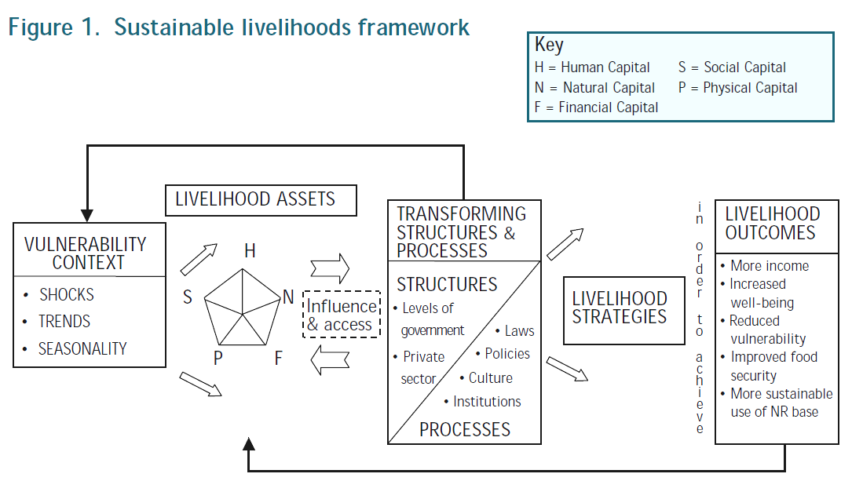
Figure: DFID. (1999). Sustainable Livelihoods Guidance Sheets. London: Department for International Development (DFID).

References
Chambers, R. & Conway, G. (1991). Sustainable rural livelihoods: practical concepts for the 21st century. IDS discussion paper, 296: IDS.
Davies, J., White, J., Wright, A., Maru, Y., & LaFlamme, M. (2008). Applying the sustainable livelihoods approach in Australian desert Aboriginal development. The Rangeland Journal, 30(1), 55-65.
McLean, J. E. (2015). Beyond the pentagon prison of sustainable livelihood approaches and towards livelihood trajectories approaches. Asia Pacific Viewpoint, 56(3), 380-391.
Morse, S & McNamara, N. (2013). Sustainable Livelihood Approach: A Critique of Theory and Practice. Dordrecht: Springer Netherlands (Chapter Two, pp. 15-60).
Radcliffe, S. (2014). Rethinking Development. In P. Cloke, P. Crang, & M. Goodwin (Eds.), Introducing Human Geographies (pp. pp. 312-323). Routledge.
Rist, G. (2014). The history of development: from Western origins to global faith (P. Camiller, Trans.; Fourth ed.). Zed.
Routledge, P. (2014). Survival and Resistance. In P. Cloke, P. Crang, & M. Goodwin (Eds.), Introducing Human Geographies (3rd ed.). Routledge.
Scoones, I. (2009). Livelihoods perspectives and rural development. Journal of Peasant Studies, 36(1): 171-196.
Willis, K. (2014). Theories of Development. In P. Cloke, P. Crang, & M. Goodwin (Eds.), Introducing Human Geographies (Vol. 3rd). Routledge.

NOTES ON THE WRITTEN REPORT

TOPIC – The livelihoods of Martu Traditional Owners in the Pilbra in WA

Firstly, thank you for taking the time to help me with this assessment – below I have outlined everything you will need to complete this. Please follow the instructions and the brief above and the guide outlined below to write this up.

Intro – the Martu is an Indigenous group in Western Australia
The guide below is a guide to each paragraph and all the points that are necessary for this essay. Please read and synthesise the sources that I have included here as they are essential for this essay.
Here are only a few sources you will need – please find more academic sources
- https://static1.squarespace.com/static/5ba1d67012b13ff5f6e56f11/t/6135befacfb2f9010adeeac1/1630912257083/KJ+evaluation+report+1+-+KJ%27s+performance+against+Martu+outcomes_FINAL.pdf
- https://www.soas.ac.uk/cedep-demos/000_P528_RF_K3736-Demo/unit1/page_22.htm
- https://static1.squarespace.com/static/55eef123e4b087ad372e72cf/t/5630ec81e4b0f64b5f80e3db/1446046849637/CoddingSAR.pdf
- Ian Scoones (2009) Livelihoods perspectives and rural development, The Journal of Peasant Studies, 36:1, 171-196,DOI: 10.1080/03066150902820503
- https://www.jstor.org/stable/25470536
- https://research-repository.uwa.edu.au/en/publications/to-hunt-and-to-hold-martu-aboriginal-peoples-uses-and-knowledge-o
- https://www.kj.org.au/meet-the-martu
- https://www.natureaustralia.org.au/what-we-do/our-priorities/land-and-freshwater/land-freshwater-stories/martu-living-deserts/
- http://www.wdlac.com.au/martu/

