Case Study: Pet Life

Goods and services procurement

Sailau Fuimaono - 19054593

2022

Contents

Executive Summary 1

Introduction 1

Discussion 1

Conclusion 1

Recommendations 2

Reference List 2

## 

## Executive Summary

## Introduction

Pet Life is a publication for animal enthusiasts and pet owners. It is a free magazine that is distributed around New Zealand via pet stores, vet clinics, pet friendly businesses and libraries. The publication is also available to view online through the website. The business operates from Kaikoura, South Island and it features regularly what is new, vet articles, rescue group superstars, freebies and a comprehensive list of welfare and rescue groups. You can also find that the magazine includes intriguing and informative articles on a broad range of pet-related topics (Pet Life, 2015). Pet Life offers inexpensive advertising for anything pet related. This keeps the business flowing as Pet Life had built a large following on social media, and especially amongst Facebook followers who share the online link to Pet enthusiast groups. Pet Life can be found anywhere and is well known amongst Pet people who have spread the word and made many likeminded people of what Pet Life is all about. They have built great followings on social media which is their strongest marketing tool and therefore they are able to provide such a big following which pet businesses or services would aim to advertise with. This is beneficial for Pet Life and its revenue and growth (NZEntrepreneur, 2017).

The procurement strategy for Pet Life is important because the long-term growth, operating outcomes, plans and revenue can all be directly affected by purchasing. The purchasing process for Pet Life is that we build great relationships with our suppliers which are our printing and paper suppliers, the distribution and delivery of our magazine and the other services that distribute our magazine in their stores. We must source the best suppliers that help us with cost savings, but it is important that the standard is kept for our magazine. With our magazine being a free magazine, there isn’t such a high demand for highly expensive quality material of the magazine so therefore we are able to source the right supplier for the paper and then the printing. We have developed agreements with our suppliers and have ensured that prompt payments are made. The procure-to-pay process also needs to be managed well to ensure that we are working through the systems efficiently and effectively. The below table is what we use as a guide through the policies and procedures of purchasing.

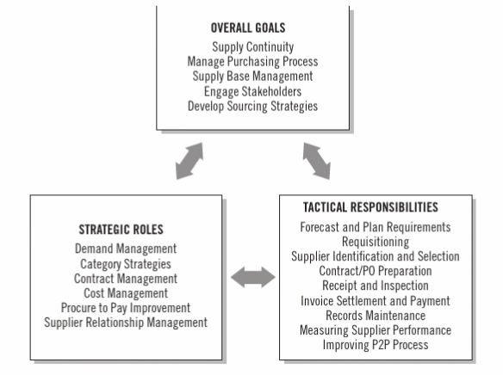

(Exhibit 2.1 pp 43. Monczka et al, 2020).

We also need to select and develop the management of suppliers which is supplier management – we need to have competitive suppliers, suppliers with excellent potential that we can build close bonds with and manage efficiently. The goals must be aligned with our stakeholders so that we have the maximum benefits for all.

## Discussion

## Scenario Analysis

## Recommendations

## Reference List

PetLife website <https://www.petlife.co.nz>

NZ Entrepreneur Magazine NEW ZEALAND'S ONLINE MAGAZINE FOR ENTREPRENEURS, STARTUPS AND SME BUSINESS BUILDERS <https://nzentrepreneur.co.nz/startup-watch-pet-life/>

(Monczka, R. M., Handfield, R. B., & Giunipero, L. C. (2020). *Purchasing and supply chain management*. Cengage