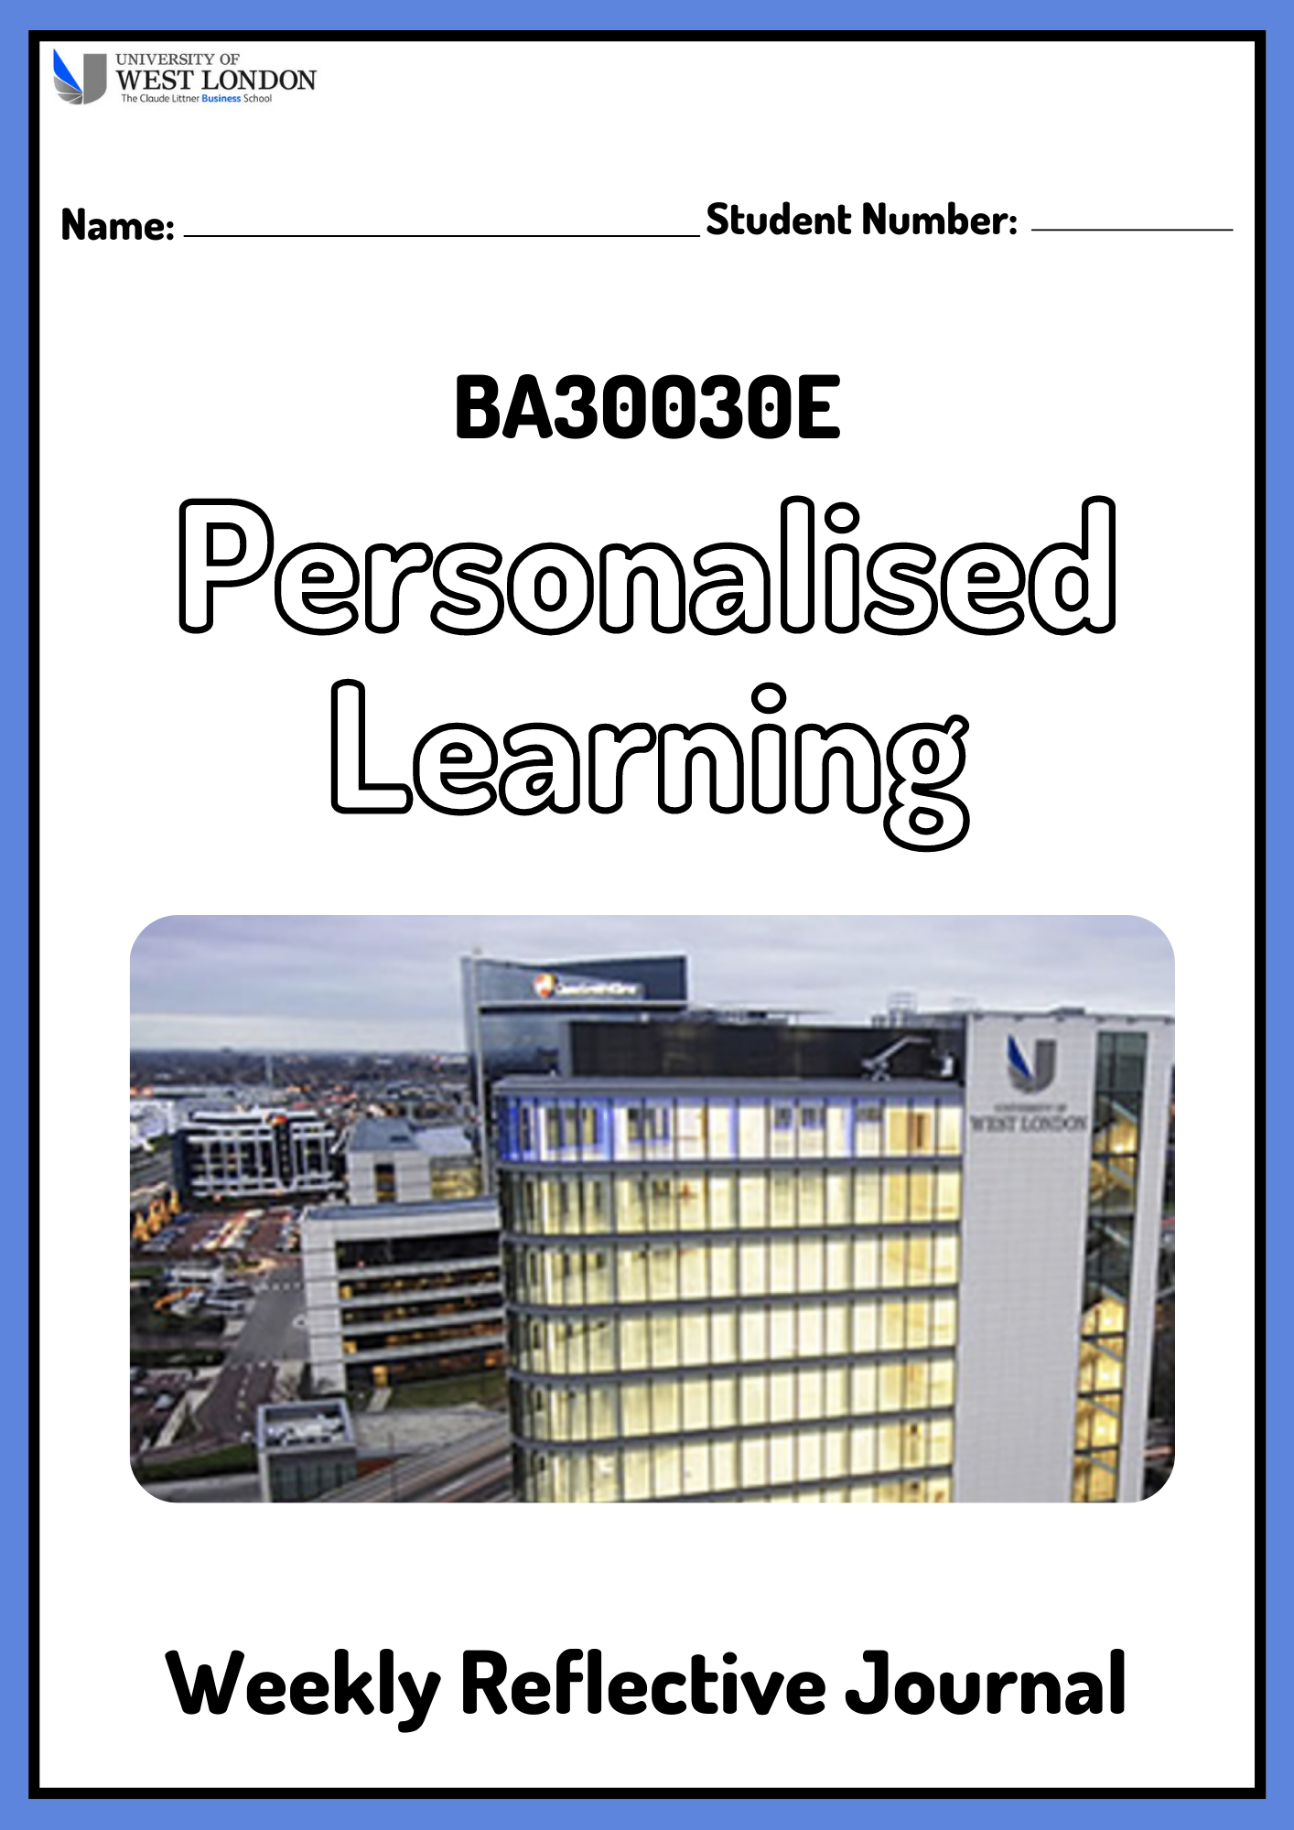
Module Leader: Dr Francisca Chiamaka Umeh
Introduction:
This template should be used to record your reflections on the weekly sessions. Please use the spaces provided to reflect on what was discussed in class, what you gained from the session; did you find the content useful, how can you relate it to your studies at university as a business student. You will also need to discuss how you intend to further develop the skills discussed in class. This is a continuous process and should be completed during the module and not at the end.
In week 8 you will be expected to submit what you have completed so far, via Blackboard, in order to receive feedback. You will then complete weeks 9 and 10 and summatively submit the journal in week 15.
The Weekly Reflective Journal will be used in conjunction with your Personal Learning and Development Plan and Interview to work out the final grade for this module. Submission of all parts of the assessment are required in order to receive a grade.
Part A: Reflective Journal

Week 1
Please describe in less than 200 words what was discussed in this session and how you plan to develop these skills.
Jbv7tvfutgviviuhb

Week 2
Please describe in less than 200 words what was discussed in this session and how you plan to develop these skills.

Week 3
Please describe in less than 200 words what was discussed in this session and how you plan to develop these skills.

Week 4
Please describe in less than 200 words what was discussed in this session and how you plan to develop these skills.

Week 5
Please describe in less than 200 words what was discussed in this session and how you plan to develop these skills.

Week 6
Please describe in less than 200 words what was discussed in this session and how you plan to develop these skills.

Week 7
Please describe in less than 200 words what was discussed in this session and how you plan to develop these skills. Use a minimum of one academic source and reference this.

Week 8
Please describe in less than 200 words what was discussed in this session and how you plan to develop these skills. Use a minimum of one academic source and reference this.
This journal should be formatively submitted for feedback, via Blackboard, at the end of this week.

Week 9
Please describe in less than 200 words what was discussed in this session and how you plan to develop these skills. Use a minimum of one academic source and reference this.

Week 10
Please describe in less than 200 words what was discussed in this session and how you plan to develop these skills. Use a minimum of one academic source and reference this.

Part B: Personal Development Plan

Part B: Personal Development Plan
Name:
Degree pathway:

Section 1 – Personal Analysis
Strengths | Areas for further development
Opportunities | Threats

Section 2 - Setting goals
What do I want to learn? | What do I have to do? | How will I measure success? | Target date for review?

Section 3 – Personal Objectives
Short-term goals (next 12 months)

Medium term goals (next 2-3 years)

Longer term goals (beyond 3 years)

This PLDP should be formatively submitted for feedback, via Blackboard, at the end of this week.
Part C: Interview (30%)
Students must bring their completed reflective journal and personal learning and development plan to this interview for discussion. The reflective journal and personal learning and development plan must be submitted, via Blackboard, at the end of week 15.

