student

[Company name]  [Company address]

Introduction to business



**Introduction to Business**

**Table of Contents**

**Executive Summary**

**Introduction to Business Studies**

**Assessment Guidelines**

**Task 1 – Group Work (Only 1 person from the group will submit)**

**The final presentation should contain.**

* **7 – 10 Slides (Excluding Title and Referencing Slides)**
* **6 – 8 references are required in Harvard Referencing style**
* **It I important to provide lecture notes in each slide**
* **Always use picture for better presentation**

**Slide 1:**



* You need to write title of the slide and name of the selected company
* Write Bucks ID number with names of all the group members

**Slide 2:**

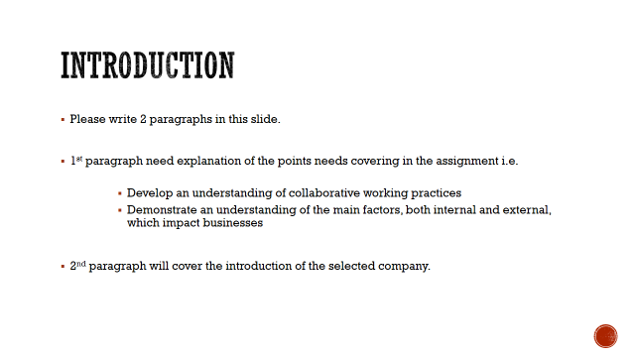

**Slide 3:**

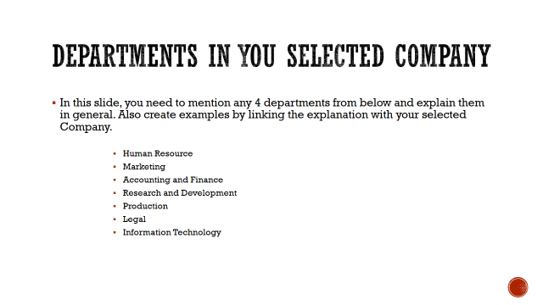

**Slide 4:**

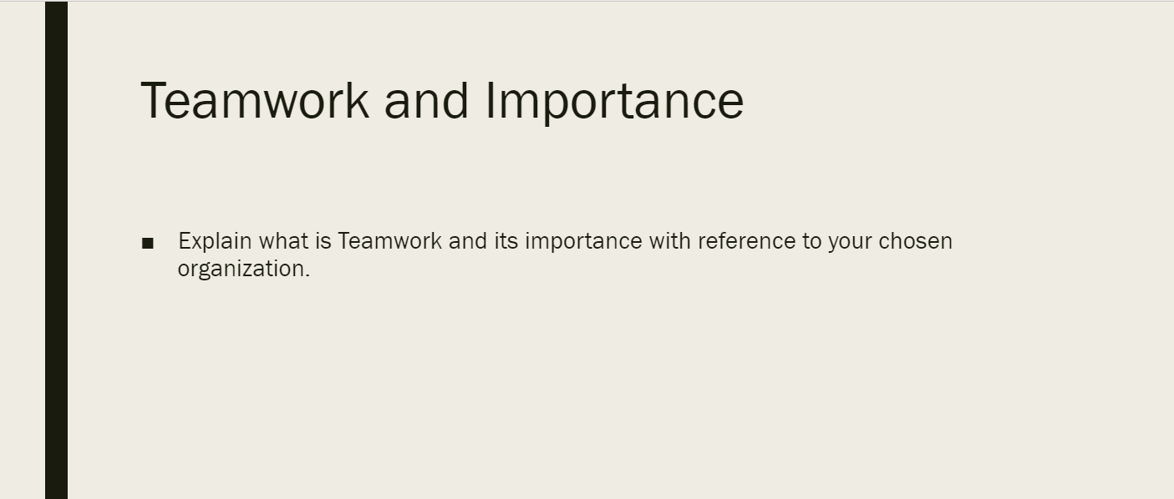

**Slide 5:**

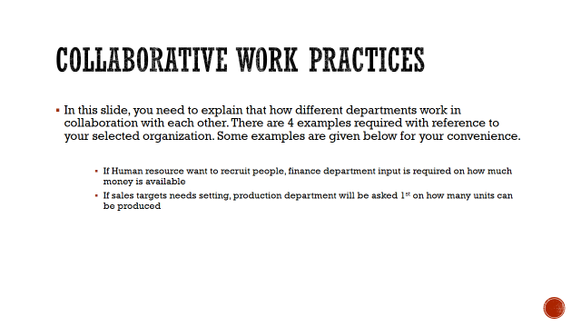

**Slide 6:**

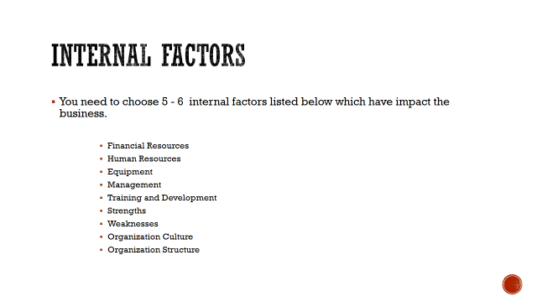

**Slide 7:**

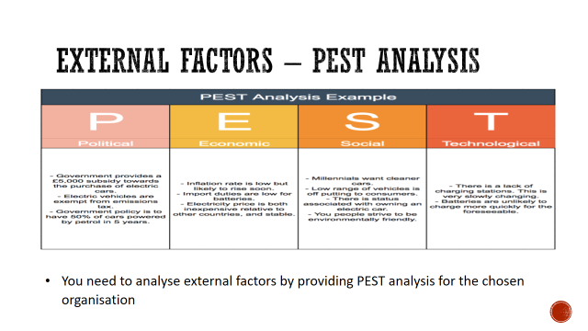

**Slide 8:**



**Slide 9:**



**Task 2 – Individual Work**

Choose a business or an organisation. Produce a poster to demonstrate **one of the 4 P's** that make up the marketing mix: **Price, promotion, place or product.**

1. One slide of PowerPoint, as a poster
2. It must have the following elements
   1. Colourful (background, boxes, different coloured font etc)
   2. Images (relevant to the topic)
   3. Information – relevant to the business and marketing mix chosen
3. Poster not to be submitted on blackboard separately
4. Samples will be shown as guidance

**Task 3 – Report on Human Resources**

**Assessment Guidelines**

**Word Count**

**Task 3 – 1000 on Human Resource (+-10%)**

**Task 4 - 1000 on Financial Management (+-10%)**

**Total Word Count: 2000 Words**

**General Instructions:**

Font: Arial / Times New Roman

Font size: 12

Font colour: **Black** only

Headings: **Size 14, Bold** and underlined

Sub-headings: **size 12** and **Bold**

**Scenario:**

You have been appointed as HR Officer and have been requested by the Director to discuss the role of HR managers in **motivating** employees or **recruiting** employees or **culture** of the organisation or **orientation**/training. You only need to choose **one of these areas** of HR (not all of them).

For 1st part of Human Resource, please choose one of the following topics from below.

1. Motivation
2. Recruitment

**If you Choose area of motivation.**

* 1. For your **case study** you need to **choose a business/company** that you can research about. You can use the same company you did for your poster, or the company you did for your group presentation, or you can choose a new company. Give some background (information) about the company you are researching about.
  2. Introduction of topic
  3. Definition of Human Resource (With Reference)
  4. Definition and Explanation of motivation
  5. Talk about **2 motivational theories** and link this with chosen organisation. For example, Maslow’s Hierarchy of needs, Herzberg’s 2-way theory, McGregor’s X and Y Theory etc. You can choose to put in diagrams, charts etc. for better presentation of the contents.
  6. How is the chosen company of your case study motivating their employees? What steps have they taken or are taking to ensure their employees remain motivated?
  7. List of References - (the references are not part of your word count)

**If you Choose area of Recruitment.**

* 1. For your **case study** you need to **choose a business/company** that you can research about. You can use the same company you did for your poster, or the company you did for your group presentation, or you can choose a new company. Give some background (information) about the company you are researching about.
  2. Introduction of the topic
  3. Definition of Human Resource (With Reference)
  4. Definition and explanation of recruitment.
  5. Talk about 2 recruitment models / theories - you can choose to put in diagrams, charts etc. for better presentation of the contents.
  6. 6th part: How is the chosen company of your case study recruiting people? How do they make sure they recruit the right people?
  7. List of References (the references are not part of your word count)

**Task 4 – Financial Management**

1. Introduction of the topic
2. Definition and explanation of Financial Management.
3. Importance of financial functions within organisations (general, not specific to an organisation)
4. Describe is the role (job) of the Financial Manager in a company? (General role)
5. Sources of Finance (With examples and references)
6. What sources of Finance are available to an organisation? What options does a business have to get capital (funds/money) to start or run the business – mention short-term and long-term finance options.
7. List of References (the references are not part of your word count)

**Conclusion:**

Add conclusion for Task 3 and Task 4.

**List of References**

Just add references for Task 3 and Task 4.

**Appendix:**

Add any other useful information which is not a part of word count.

**Notes:**

* **Correctly** use the **Harvard Referencing System** for **in-text citation** and the **Reference section** of the report.
* **Data should be added with graphs**

**Good Luck 😊**