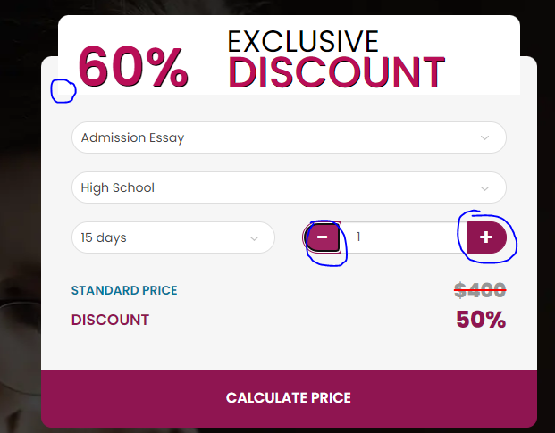

There is no difference in Discount and Order form. 1 of them should be a bit darker.

Page changes not working

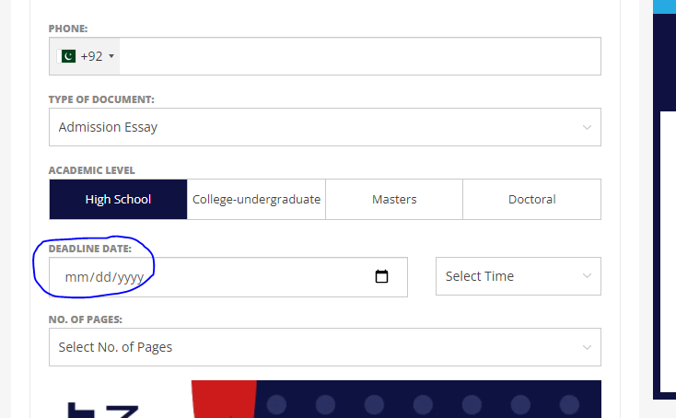

When deadline selected on home page, it should be auto selected here as well, same goes with the no of pages.



Change the code from PPL to AHT

I selected half payment and it shows full here

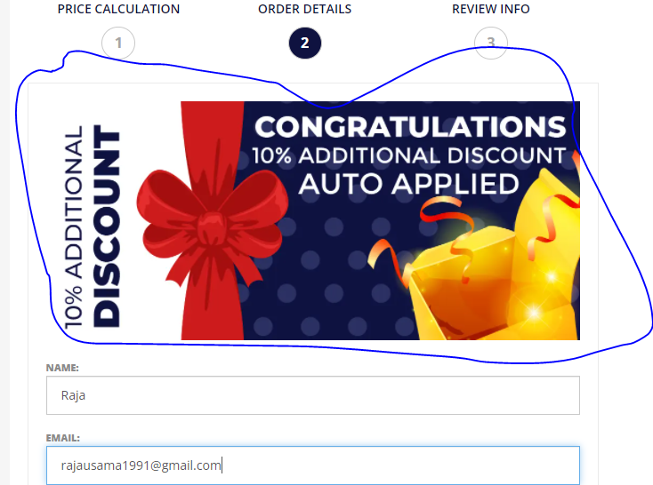

It should be a bit smaller

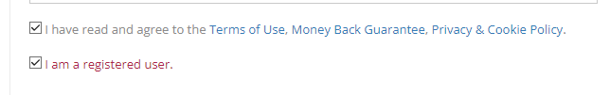

Remove the terms and conditions check

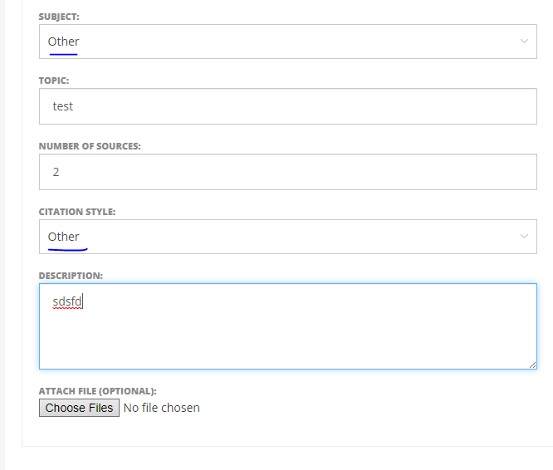

Upon selecting other, another box open below subject where customer can write down manually about other subjects and citation styles