Part A
You work in the corporate finance division of Singapore Airlines Limited and your boss has asked you to review the firm's capital structure. Specifically, your boss is considering changing the firm’s debt level. Your boss remembers something from his MBA program about capital structure being irrelevant, but isn't quite sure what that means. You know that capital structure is irrelevant under the conditions of perfect markets and will demonstrate this point for your boss by showing that the weighted average cost of capital remains constant under various levels of debt. So, for now, suppose that capital markets are perfect as you prepare responses for your boss. You would like to analyze relatively modest changes to Singapore Airlines' capital structure. You would like to consider two scenarios: the firm issues $1 billion in new debt to repurchase stock, and the firm issues $1 billion in new stock to repurchase debt. Use Excel to complete Table 1 (following the guidelines provided below), assuming a cost of unlevered equity ( U r ) of 12%. Besides, when you work on Table 1, you notice the share price is volatile and quite uncertain due to the COVID-19 pandemics. You wish to include a sensitivity analysis which considers situations that share price increases or decreases by 10% (thus leverage ratio would be changed). In Part A of your report, prepare a written explanation for your boss explaining the relationship between capital structure and the cost of capital. The completed Table 1 should be included to serve as your illustration. Besides, make a comment on how sensitive your analysis is when the share price increases or decreases by 10%, supported by Table 2.
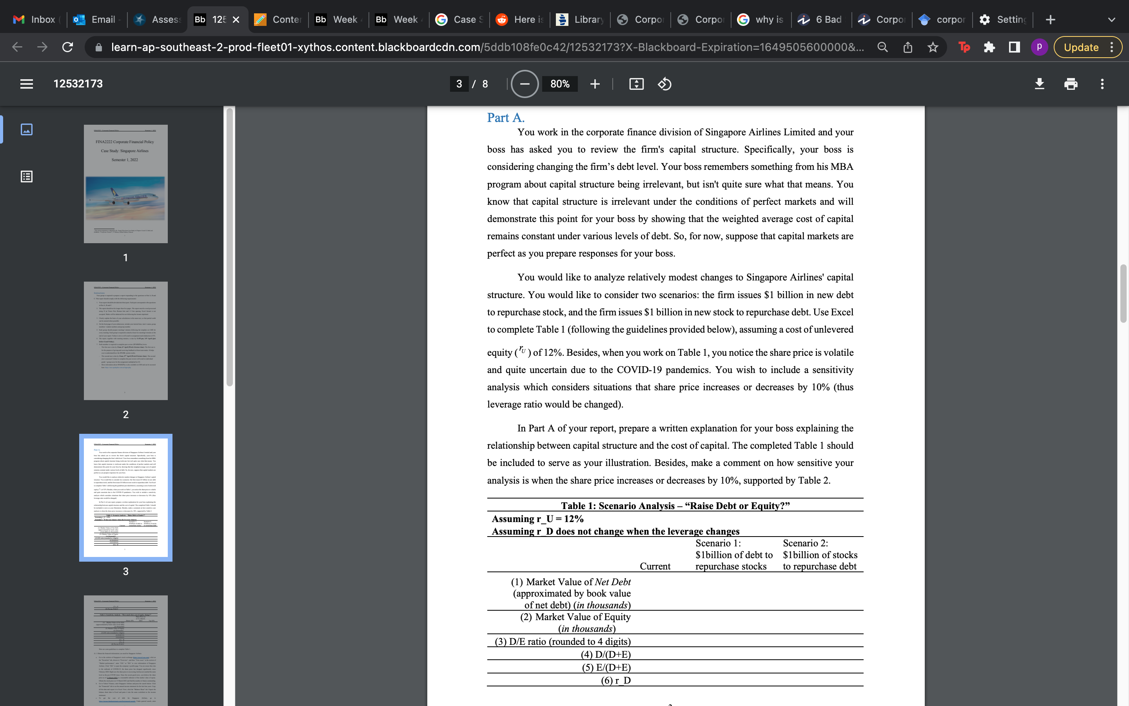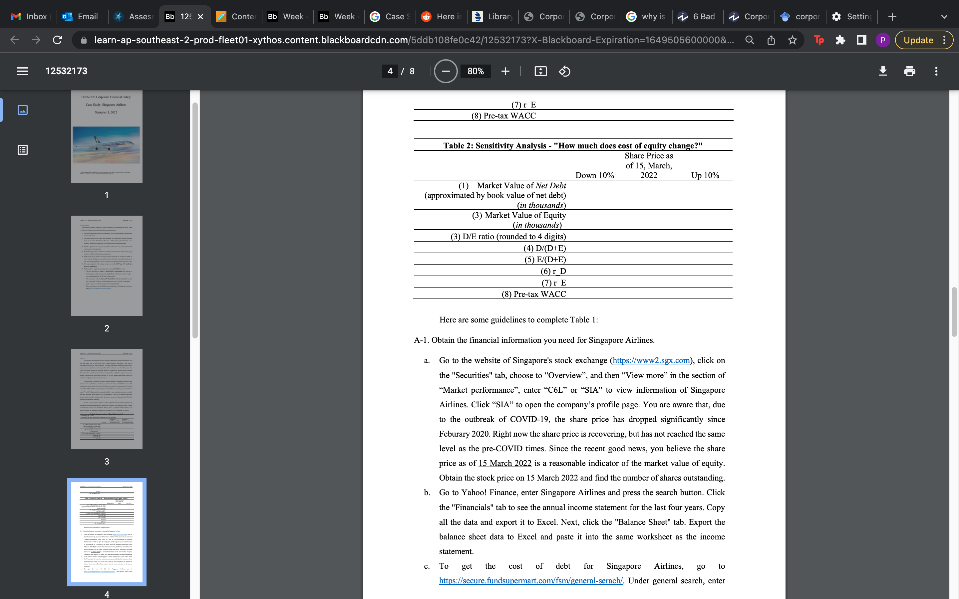

Here are some guidelines to complete Table 1: A-1.
Obtain the financial information you need for Singapore Airlines.
a. Go to the website of Singapore's stock exchange (https://www2.sgx.com), click on the "Securities" tab, choose to “Overview”, and then “View more” in the section of “Market performance”, enter “C6L” or “SIA” to view information of Singapore Airlines. Click “SIA” to open the company’s profile page. You are aware that, due to the outbreak of COVID-19, the share price has dropped significantly since Feburary 2020. Right now the share price is recovering, but has not reached the same level as the pre-COVID times. Since the recent good news, you believe the share price as of 15 March 2022 is a reasonable indicator of the market value of equity. Obtain the stock price on 15 March 2022 and find the number of shares outstanding.
b. Go to Yahoo! Finance, enter Singapore Airlines and press the search button. Click the "Financials" tab to see the annual income statement for the last four years. Copy all the data and export it to Excel. Next, click the "Balance Sheet" tab. Export the balance sheet data to Excel and paste it into the same worksheet as the income statement.
c. To get the cost of debt for Singapore Airlines, go to https://secure.fundsupermart.com/fsm/general-serach/. Under general search, enter
"SIASP". The information of all Singapore Airlines outstanding bonds will be shown. For simplicity, since you are just trying to illustrate the main concepts for your boss, you may use the existing yield on the outstanding bond as Dr . Select the latest yield on an outstanding bond with the shortest remaining maturity (the maturity date is on the line describing each issue). In this case, you choose “25OCT2023” bond. On the page of the selected bond, click “Yield Chart” in the section of “Bond Performance”. You notice that, due to COVID-19, the market was deep down in September 2021 and then rising since then. You decide to use the information on 15 March 2022 to do your analysis. Obtain the "Ask Yield to Maturity." A-2. Compute the market D/ E ratio for Singapore Airlines. Approximate the market value by the book value of net debt as of 31/03/2020. Book value of net debt is calculated as “Long-Term Debt” plus “Short-Term Debt & Current Portion of Long-Term Debt” subtract any cash holdings.2 Use the stock price and number of shares outstanding (obtained from step A-1.a) to calculate the market value of equity. [Rounded to 4 digits] A-3. Based on MMII, compute the cost of levered equity ( Er ) for Singapore Airlines using their market debt-to-equity ratio and the formula ( ) EU UD D rr rr E =+ − . A-4. Compute the weighted average cost of capital (pre-tax WACC listed in Table 1) for Singapore Airlines given their debt-to-equity ratio. A-5. Repeat Steps 3 and 4 for the two scenarios you would like to analyze, issuing $1 billion in debt to repurchase stock, and issuing $1 billion in stock to repurchase debt. (Although you realize that the cost of debt capital Dr may change with changes in leverage, for these modestly small changes you can assume that Dr remains constant.) Here are some guidelines to complete Table 2: A-6. Copy your first column of Table 1 into the middle column of Table 2; A-7. In column “Down 10%”, change the market value of equity to be 90% of the current market value of equity and complete the rest of the calculations; and, in column “Up 10%”, change the market value of equity to be 110% of the current value and complete the rest of calculations.
Part B
Your boss, as expected, has realized that market imperfections like taxes must be accounted for. You have now been asked to include taxes in your analysis. Your boss knows that interest is deductible and has decided that the stock price of Singapore Airlines should increase if the firm increases its use of debt. Thus, your boss wants to propose a share repurchase program using the proceeds from a new debt issue and wants to present this plan to the CEO and perhaps to the Board of Directors. Your boss would like you to examine the impact of two different scenarios, adding a modest level of debt and adding a higher level of debt. In particular, your boss would like to consider issuing $1 billion in new debt or $5 billion in new debt. In either case, Singapore Airlines would use the proceeds to repurchase stock. In Part B of your report, you are expected to use both Table 3 and Table 4 to illustrate the relationship between the change of debt and the change of share price, and discuss whether it is a good idea to raise $1 billion as opposed to $5 billion of debt to repurchase stock (why or why not). In addition, please discuss potential issues that the executives of Singapore Airlines might raise and focus on issues that are not yet considered in your analysis but relates to tax imperfections. (Hint: assumptions of the formula for PV(interest tax shield))

Part C
While, you were working through the scenarios analysis, you noticed the company already raised debt and new equities in May 2020 and May 2021 which is reflected in balance sheet.4 The amount of debt and new equities are sizable. In your part C of report, you wish to reflect the change in capital structure during the COVID period and put forward some suggestions for future strategies. More specifically, you need to review why the company made the decisions of raising capitals at the time, discuss their potential impact on the wealth of shareholders, and assess whether it is a good strategy. Further, given the current capital structure (information from Part A and B), you wish to convince your boss that share buyback may not be a good idea and suggest to your boss the company’s future strategy (For example, how to use the cash in an efficient way or what’s the drawback of keeping cash). Support your arguments using relevant theories that you have learned in this unit. You are also encouraged to conduct additional research using reliable sources such as links provided in Part A and B, mainstream financial news coverage, and research articles from Google Scholarly.

