A Systematic Review and Meta-Analysis Comparing Diamond Technique versus Parachute Technique Anastomosis in Upper Limb Arteriovenous Fistula for Hemodialysis Patients:
A PRISMA-Compliant Proposal
By:

Abdelrazig salih
General and Vascular

Supervisor:

Consultant Vascular Surgeon at UHW

Introduction
Chronic kidney disease (CKD) has emerged as one of the leading causes of death and disability in the twenty-first century. The number of patients afflicted by CKD has also been increasing, owing in part to an increase in risk factors such as obesity and diabetes mellitus. In 2017, an estimated 843.6 million people worldwide were impacted by CKD [1]. Despite the emphasis on peritoneal dialysis, hemodialysis remains the most common dialysis modality worldwide. Hemodialysis is the renal replacement modality of choice for more than 60% of ESRD patients in the United States. Despite long-term hemodialysis use in ESRD patients, vascular access remains challenging, with significant morbidity and mortality rates [2]. According to current research, the arteriovenous fistula (fistula) is the preferred type of vascular access for hemodialysis [3]. When compared to arteriovenous grafts and catheters, fistulas have longer patency and reduced rates of complications once formed. However, as the proportion of aged and frail patients on hemodialysis has increased, so has the rate of failure to mature, resulting in a decrease in patency rates [4]. AVF operations are life-saving procedures for patients with ESRD and can be performed easily under local anesthesia with a success rate over 80% [4]. AVFs are usually created by end-to-side and side-to-side anastomosis techniques [5,6]. End-to-side anastomosis is performed using 4-quadrant, 2-quadrant, and parachute procedures. The diamond-shaped end-to-side anastomosis technique, commonly utilized in reconstructive surgery, has recently been applied in AVF procedures. This procedure has an 89% short-term patency rate according to reports. Various anastomosis procedures, patency, and complication rates have been reported for AVF establishment. However, no randomized studies have been conducted to compare two alternative end-to-side anastomosis procedures utilized in AVF operations. Furthermore, in previous research, AVFs were established by the entire surgical team, with no consideration given to surgeon-specific characteristics [7].

Study Aims and Objectives

The primary goal of this study is to conduct a systematic review and meta-analysis following the Preferred Reporting Items for Systematic Reviews and Meta-Analyses (PRISMA) guidelines. Key objectives include:
- Evaluating upper limb AVFs created using the diamond and parachute anastomotic techniques.
- Comparing key parameters such as fistula patency, maturation time, and complication rates associated with each technique.
- Synthesizing current evidence to provide valuable insights into the efficacy and safety of these anastomotic methods.

Methodology
Study Design:
The study will be conducted in accordance with PRISMA Guidelines.
Literature and Search Strategy:
The search will be conducted by two independent reviewers and will be done electronically, looking into databases PubMed, Cochrane Database, and Embase. The electronic search will disregard language differences and will focus on studies published within the last 15 years. The keywords to be used are “anastomosis”, “arteriovenous fistula”, “AVF”, “fistula”, “hemodialysis”, “Diamond technique”, and “Parachute technique.”
Eligibility Criteria:
The PICOS Inclusion criteria are as follows:
Population: Adult patients undergoing upper limb AVF surgery for hemodialysis.
Intervention: Diamond technique of anastomosis.
Comparison: Parachute technique of anastomosis.
Outcomes: Patency rates, maturation time, or complications.
Study Type: Both randomized controlled trials (RCTs) and observational studies. Studies published before 2009 will be omitted to ensure relevance and currency.
Exclusion Criteria:
- Single-arm studies.
- Studies with overlapping or duplicate data. For studies with duplicate data, the study reporting the maximum outcomes and with the largest sample size will be included.
Risk of Bias Assessment:
Tools like the Cochrane Risk of Bias Tool for RCTs and the Newcastle-Ottawa Scale for observational studies will be used.
Primary Outcomes: Fistula patency rates, complication rates (e.g., stenosis, thrombosis), and intervention success rates.
Secondary Outcomes: Patient survival, quality of life measures, cost-effectiveness, and length of hospital stay.
In the systematic review and meta-analysis comparing the Diamond and Parachute Techniques for arteriovenous fistula creation, several covariates and predictor variables are crucial. Covariates like patient age, comorbidities, previous vascular access history, gender, BMI, duration of dialysis, quality of blood vessels, and medication use can significantly influence outcomes. The primary predictor variable is the anastomosis technique (Diamond or Parachute) , supplemented by the surgeon’s experience, the healthcare facility's resources. These factors collectively impact the success and complication rates of fistulae, necessitating careful consideration in the analysis to accurately assess and compare the efficacy of both techniques.
Data Collection Process:
Data collection will occur independently using a piloting form. data extraction will be meticulously executed by trained reviewers using a standardized form. This form, initially piloted for efficiency, will capture crucial study details, participant demographics, and specific intervention data (Diamond or Parachute technique). Key outcomes like patency rates and complication rates, along with covariates such as patient comorbidities and surgeon experience, will be systematically recorded. Discrepancies between reviewers will be resolved through consensus or arbitration. Attention will be given to missing data, and a high standard of data quality and secure storage will be maintained, ensuring the reliability and integrity of the analysis.
Data Protection Rules:
The study will comply with data protection regulations, ensuring confidentiality and secure data handling as per the Data Protection Rules.
Plan of Analysis:
Meta-analysis will be performed using STATA version 17.
Ethical Consideration:
Respect for Privacy and Confidentiality:
- Ensure that individual patient data, if accessed, is handled confidentially. Patient identifiers should be removed or anonymized.
- Comply with data protection regulations (like HIPAA in the U.S. or GDPR in Europe) when handling patient data.
Timescale:
The systematic review and meta-analysis project spanning from January to July 2024 is structured into distinct phases. In January, the focus will be on finalizing and approving the research proposal, followed by initiating the literature search. February's agenda includes the continuation of the literature search and beginning the screening of titles and abstracts. March is dedicated to completing data extraction and initiating the quality assessment of the included studies. April will see the completion of the quality assessment and the commencement of data synthesis and statistical analysis. In May, efforts will pivot towards drafting the manuscript, with the aim of finalizing and reviewing it in June. This month also includes preparing the manuscript for submission, which is planned for early July. The latter half of July is reserved for planning the dissemination of the research findings and considering future research directions.

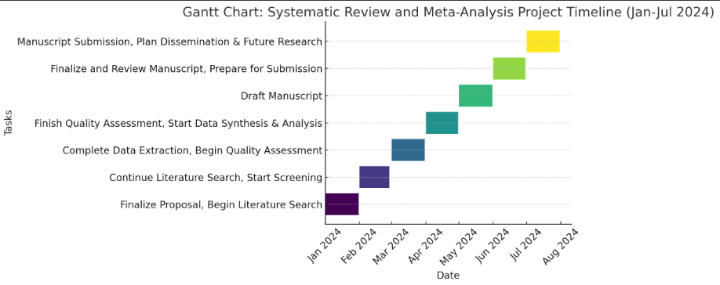

Possible Challenges to Delivering on Project:
In conducting the systematic review and meta-analysis, several contingencies could arise. Literature heterogeneity might present challenges in synthesizing data, requiring additional qualitative analysis or subgroup considerations. Delays in accessing full-text articles or discrepancies in data extraction could extend the timeline, necessitating flexible scheduling. The risk of publication bias, where studies with negative outcomes are underreported, might skew results, requiring careful assessment and possible inclusion of grey literature. Additionally, the evolving nature of research in the field may introduce new studies during the review process, potentially altering the scope or findings of the analysis.

References:
- Jager KJ, Kovesdy C, Langham R, et al. A single number for advocacy and communication—worldwide more than 850 million individuals have kidney diseases. Kidney Int. 2019;96:1048–1050.
- Zhou Y, Wu H. Comparison of end-to-side versus side-to-side anastomosis in upper limb arteriovenous fistula in hemodialysis patients: A systematic review and meta-analysis. Front Surg. 2023 Jan 6;9:1079291. doi: 10.3389/fsurg.2022.1079291. PMID: 36684232; PMCID: PMC9853376.
- Jindal K, Chan CT, Deziel C, Hirsch D, Soroka SD, Tonelli M, Culleton BF; Canadian Society of Nephrology Committee for Clinical Practice Guidelines. Hemodialysis clinical practice guidelines for the Canadian Society of Nephrology. J Am Soc Nephrol. 2006;17(Suppl 1):S1–S27.
- Al-Jaishi AA, Liu AR, Lok CE, Zhang JC, Moist LM. Complications of the arteriovenous fistula: A systematic review. J Am Soc Nephrol. 2017 Jun;28(6):1839-1850. doi: 10.1681/ASN.2016040412. PMID: 28031406; PMCID: PMC5461784
- Ganie FA, Lone H, Dar AM, Lone GN, Wani ML. Native arterio-venous fistula is the vascular access of choice for hemodialysisin end stage renal disease. Int Cardiovasc Res J 2013; 7:67-70.

- Mozaffar M, Fallah M, Lotfollahzadeh S, Sobhiyeh MR,Gholizadeh B, Jabbehdari S, et al. Comparison of efficacy ofside to side versus end-to-side arteriovenous fistulae formationin chronic renal failure as a permanent hemodialysis access.Nephrourol Mon 2013; 5:827-30
- Yabanoglu H, Kus M, Arer IM, Bali C, Avci T, Akdur A, Caliskan K. Comparison of the Early-Term Complications and Patency Rates of the Standard (Parachute) and Diamond-Shaped End-To-Side Anastomosis Techniques in Arteriovenous Fistulas Created for Hemodialysis. J Coll Physicians Surg Pak. 2018 Aug;28(8):597-602. doi: 10.29271/jcpsp.2018.08.597. PMID: 30060787.

