**End of Term 1 Online Exam 2022**

**ACCT2007 Finance for Business**

Time allowed to complete this online ‘take home’ exam is from **Saturday 16 April 2022, 9:00am** to **Tuesday 19 April 2022, 11:59pm (AEST)**. The exam has been designed so that it can be downloaded, completed and submitted in around 4 hours start to finish. Only ONE attempt and submission is permitted, so please ensure the exam paper you submit for grading is correct and FINAL. Note: Late submissions will be penalised.

You must complete your exam on this exam paper document by **typing** your responses under each question stated below. You can expand the space under each question if needed. Do NOT take photos of written (or typed) work and paste into the exam paper. If you do this, it will not be accepted or graded.

This is an OPEN BOOK exam where the use of study resources such as unit content, textbooks, workshop/tutorial materials, etc. are permitted. Your completed exam Word document is submitted through Turnitin, hence academic standards of referencing and originality are mandatory.When complete, upload your exam document to *Assessment Details and Submission* on the ACCT2007 MySCU learning site via the Turnitin exam submission link by the specified deadline. Save your Word doc exam paper as: *ACCT2007 Online Exam_LastName_FirstName_StudentID*

**EXAM DETAILS**

* + The OPEN BOOK online exam is marked out of 50 and worth 50% of the unit assessment.
  + To obtain a passing grade in this unit, students must (1) obtain a score of at least 50% overall for the unit; and (2) attempt all assessment items.
  + The exam consists of five (5) questions:
    - Question 1 @ 5 marks
    - Question 2 @ 5 marks
    - Question 3 @ 10 marks
    - Question 4 @ 15 marks
    - Question 5 @ 15 marks
  + Questions will be a mix of conceptual and calculation-based questions. Note: there are no multiple choice questions.
  + Each question may include sub-parts (e.g., 1a, 1b, etc.).
  + The exam questions may cover content from any of the six (6) Modules taught in this unit.
  + Students are to attempt ALL questions.
  + Full calculation workings/answers are required and academic referencing will be needed for written responses where you are citing materials.
  + Provide your typed answers (including any embedded Excel calculation workings) and references (including reference list) in the exam paper.
  + There is no word limit in this exam.
  + There is no sample exam for this unit.

**Before commencing the exam, please enter the following identifying information.**

**Name:**

**Student ID:**

**Enrolment Location:**























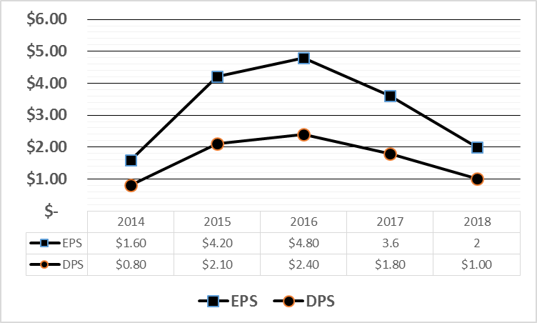





**END OF EXAM**