**Students will form groups of up to three students and develop a project proposal in response to a natural or human-made disaster at a local or national level of their choice - Cyclone Tiffany at Groote Eylandt Community - 2022 January 10-11**

Student groups should imagine themselves as a team of social workers asked to develop a project proposal for a community-based response to the disaster and its impact on local communities, families and individuals.

The response will draw from eco-social work theories and community work approaches and link these strategies to social work theory, practice and values. A possible format for the proposal is provided below.

**Chosen Disaster - Cyclone Tiffany at Groote Eylandt Community - 2022 January 10-11**

**Group Project Proposal:**

An International Social Work Alliance is funding projects to respond to natural or human made disasters at local or national levels (**Cyclone Tiffany at Groote Eylandt Community - 2022 January 10-11)**

As a social work-based funding program all projects need to draw from social work theories and practice, and be congruent with social work ethics and values. Community based projects that incorporate eco social work will be funded.

Projects need to:

• Address the climate crisis and contribute to an environmentally sustainable future.

• Be local and regional community-based responses that encourage community decision making.

• Address the diversity, needs, strengths and vulnerabilities within communities, and contribute to a socially just and equitable society.

Projects must be able to be completed within a 12-to-24-month timeframe and funding from $10,000 to $250,000 is available

**Project summary (400 words) - Shanayah**

A short description of the project. A description of the disaster the project is addressing and its impact on groups and communities providing key information about the wider context (A description of the community impacted by your disaster and unique characteristics including political, cultural and economic. Any social groups that your project will particularly focus upon and rationale for this decision.).

**Evidence informed projects (800 words)**

Details of previous projects, studies or research this project design can draw from Explain how the previous project findings can be used to support your proposed project (synergies and gaps).

**Project details (1800 words) - Joshua**

**-Details of why this project is needed**

**-A clear explanation of what the project seeks to achieve (e.g. how particular social groups will benefit from this project)**

**-Foreground social work theories(2x) and strategies(community approach 2x) that will be used.**

**-Anticipated challenges and how they will be managed.**

**-Anticipated outputs, outcomes, and impact of the project (consider the project flow diagram below).**

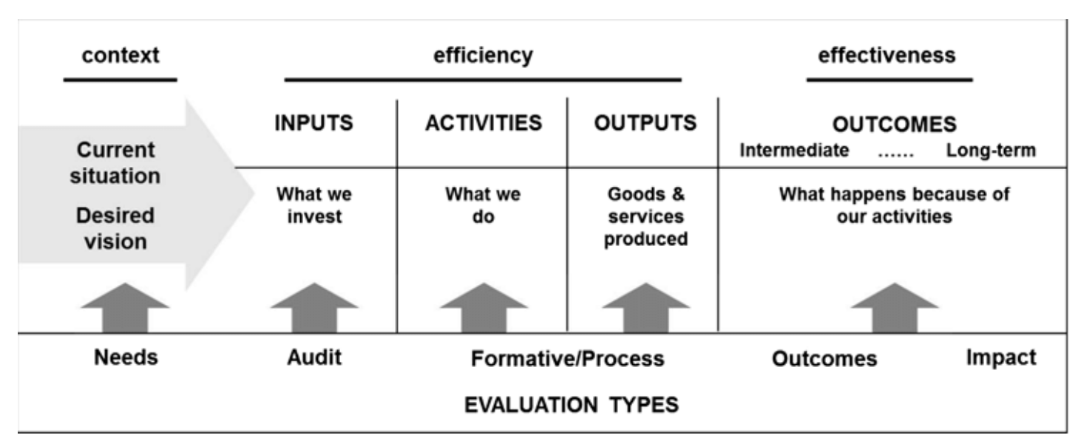

**The proposal needs to include APA 7 referencing. Plagiarism should be avoided by careful paraphrasing and quoting of source material, although quotes should be kept to a minimum**

**Community Participation (500 words) - Hannah**

Detail the community participation methodology or principles you will apply, including any groups or communities you will partner with.

**Inclusion and sustainability (500 words)**

Describe how your project contributes to social inclusion and equity and addressed systemic discriminations including for Indigenous groups and communities. Describe how your project will address the climate crisis and environmental sustainability issues.

LINKS that may be relevant

[Tropical Cyclone Tiffany: 10-11 January 2022 (disasterassist.gov.au)](https://www.disasterassist.gov.au/Pages/disasters/current-disasters/Queensland/tropical-cyclone-tiffany-10-11-january-2022.aspx)

<https://www.abc.net.au/news/2022-01-11/nt-cyclone-tiffany-groote-eylandt-housing-concerns/100750264?utm_campaign=abc_news_web&utm_content=link&utm_medium=content_shared&utm_source=abc_news_web>

[Tropical Cyclone Tiffany: January 2022 (disasterassist.gov.au)](https://www.disasterassist.gov.au/Pages/disasters/current-disasters/Northern-Territory/tropical-cyclone-tiffany-january-2022.aspx)

[Home | Queensland Reconstruction Authority (qra.qld.gov.au)](https://www.qra.qld.gov.au/)

[Tropical Cyclone Tiffany 2022: BOM warns of Queensland floods and severe weather as conditions worsen into category two storm | 7NEWS](https://7news.com.au/news/qld/amid-flooding-qld-warned-to-take-cover-as-cyclone-tiffany-gathers-strength-near-coast-c-5244791)

[Tiffany2022_Report.pdf (bom.gov.au)](http://www.bom.gov.au/cyclone/history/pdf/Tiffany2022_Report.pdf)

[(63) Groote Eylandt residents preparing for ex-Tropical Cyclone Tiffany to regain intensity | ABC News - YouTube](https://www.youtube.com/watch?v=VaCrkXLIZDU)