|  |  |
| --- | --- |
| **Assessment 1 Nursing case study report** | **(2500 words)** |
| **Component of the assessment scheme** | **30%** |
| **Due Date** | **31 March 2023 @ 1700** |
| **Submission Process** | **Via Learnonline** |

This assessment will consist of a nursing case study report.

**Assessment Aim:**

According to the Nursing and Midwifery Board of Australia’s (2016) *Registered nurse standards for practice,* nurses need to be able to;

* Think critically and analyse nursing practice (Standard 1),
* Comprehensively conduct assessments (Standard 4),
* Develop a plan for nursing practice (Standard 5),
* Provide safe, appropriate, and responsive quality nursing practice (Standard 6),
* Evaluate outcomes to inform nursing practice (Standard 7).

Thus, the aim of this assessment is to provide students with an opportunity to analyse and evaluate a clinical case scenario so that the development of critical thinking and reflection is promoted. In this assessment, students will be required to interpret clinical information and draw upon their knowledge of pathophysiology, the nursing process and evidence-based nursing practice, and articulate new learnings in the case study report.

**What you need to do:**

Based upon the clinical scenario provided below, construct a case study report. This includes a detailed report of the person’s clinical presentation, nursing management and inter-professional plan of care. The case report will draw upon your knowledge of pathophysiology, pharmacology, and relevant academic literature to support an evidence-based nursing plan of care.

The case report must be presented using the headings provided below. A description of the content for each section of the report has been provided. It is important that all sections of the report are conceptually connected. For example, your knowledge of pathophysiology and pharmacology, and your understanding of this person, should underpin the identified nursing problems. In turn, evidence-based nursing care and interprofessional care that relate to the problems should be clearly discussed and must be relevant to the clinical scenario.

## Case Report:

The case report must include the following:

**Introduction - 200 words**

Using the ISBAR clinical handover framework, introduce the person and provide a brief overview of their case. Provide an outline of the purpose and structure of the report.

**Primary admission - 300 words**

In this section provide a summary of the reasons why the person was admitted to hospital. For this, include a brief description of the pathophysiology of the person’s medical problems and their clinical manifestations. Support this discussion with contemporary, evidence-based literature.

**Identify two (2) nursing problems (300 Words)**

Using the previous description of the pathophysiology and observed clinical manifestations, **identify two (2) nursing problems that are to be prioritised for the person**. Justify your selection and briefly describe why each is important in the person’s management. Support your discussion by utilising contemporary, evidence-based literature.

*Tip: Importantly in this section, you should prioritise the care that is required by the person. Consider what is the most pressing concern for the person at this stage.*

**Nursing management (1000 Words – 500 words per problem)**

In this section, you will focus on the implementation of the nursing process to each of the identified problems from the section above. That is, for **each** identified problem you will need to include a discussion of;

* One (1) appropriate nursing assessment and its rationale,
* One (1) appropriate nursing intervention related to your assessment. Provide a rationale for each intervention,
* Nursing implications related to the medication management of the ongoing management of each problem.

Support your discussion by utilising contemporary, evidence-based literature.

*Tip: This section of the report focuses on assessments and interventions that the Registered nurse (RN) conducts. Remember to discuss what the RN physically does to provide optimal person-centred care as part of the nursing management plan.*

**Discharge planning (500 Words)**

The discharge plan must focus on the interdisciplinary management for this person and should refer to the nursing problems addressed throughout the report.

In this section, discuss the aim of discharge planning and the importance of using an interdisciplinary approach. Also, discuss the role of the RN in facilitating a multidisciplinary discharge plan for this person. **Identify and justify** the members of the multidisciplinary health care team and the role that they would play. For this, you should refer back to the identified nursing problems discussed in the report.

*Tip: Avoid reverting to simple referrals to other members of the health team.*

**Conclusion (200 Words)**

Summarise the major findings of this case report. The conclusion should not introduce new material that has not been previously addressed within the report.

## Referencing

The content of the case report must be supported through referencing of current evidence-based literature and must include a reference list and intext citations. Students will be assessed on referencing and academic writing.

Please refer to following.

* [Health of Adults Assessment Help on Learnonline](https://lo.unisa.edu.au/course/view.php?id=27566&sectionid=637806)
* [Referencing Information](https://lo.unisa.edu.au/course/view.php?id=3839) from the library.

**Overall writing and presentation**

As per [Academic Writing Requirements](https://lo.unisa.edu.au/pluginfile.php/3202779/mod_book/chapter/321460/Academic_Writing_Requirements%202021.pdf), this assignment must be saved and submitted as a word document. This case report must be structured using the headings provided and presented using academic writing. The use of dot-points will result in a reduction of marks. You will be assessed on the overall writing and presentation – compliance with the academic writing guidelines will avoid loss of marks for this assessment.

## Clinical Scenario: NURS 2023 Health of Adults Case Study.

Identify

Patient Name

Mrs. Christine Hynde

Age/Date of Birth

58 years, Date of Birth: 10 February 1965

Sex

Female

Situation

Mrs. Hynde presented to the emergency department complaining of shortness of breath and heart palpations. She looks anxious, and her complexion is ruddy and notably she is breathing through pursed lips.

A 12-lead electrocardiogram (ECG) was obtained and presented to the attending team for review.

The ECG demonstrates an atrial arrythmia.

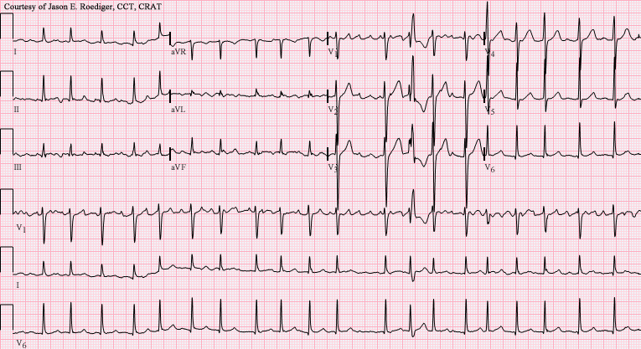

Background

Mrs. Hynde is married with 2 children that live interstate. She admits that her health has been deteriorating over the past 2 years. Consequently, he husband Gary, has become her primary carer.

One of the things that you notice is that Gary is expressing signs of carer burden by stating that looking after his wife is becoming increasingly difficult, particularly in the last two months.

Mrs. Hynde’s past medical history includes:

* Type 2 diabetes mellitus,
* Peripheral vascular disease with limited mobility, she can only walk five to 10 m before becoming breathless,
* Chronic Obstructive Pulmonary Disease (COPD),
* Hypercholesterolaemia,
* Depression,
* Hypertension (poorly controlled),
* Reformed smoker - 25 cigarettes a day, quit 5 years ago,
* Body Mass Index (BMI): 26.

Mrs. Hyndes currently prescribed medications include:

* Perindopril (8mg daily),
* Atorvastatin (80mg daily),
* Metformin (500 mg bd),
* Terbutaline (5 mg tds).

Assessment

Mrs. Hyndes appears to be restless and very anxious. Her breathing is labored, and she continues to breathe through pursed lips. A repeat ECG confirmed that she is in rapid atrial fibrillation with a ventricular response rate over 100 beats per minute.

Recommendations

Thus, it was recommended that;

* She is admitted to cardiac ward for monitoring.
* Oxygen therapy to be titrated to maintain an oxygen saturation > 93 %.
* Commencement of Amiodarone infusion 300 mg to be administered over 2 hours.
* Routine blood analysis including full blood examination, electrolytes and urea, coagulation studies and high sensitivity troponin levels.
* Strict fluid balance chart to commence.
* Repeat ECG.
* Position for optimal respiration.
* Mobilise as tolerated.

Nursing Handover

It is 24 hours post admission, you are about to start your early shift in the cardiac unit and Mrs. Hyndes is your allocated patient.

During the morning bedside handover, the night duty Registered nurse (RN) reports Mrs. Hyndes;

* Had a restless night, slept for short periods only and at times was disorientated.
* Vital signs (last measured at 0600):
  + - Temperature: 37.6oC.
    - Heart rate: 100 beats per minute and irregular.
    - Respiratory rate: 24 breaths per minute.
    - Blood Pressure: 100/50 mmHg.
    - Sa02: 92 % on 2L via nasal specs.
* Mrs. Hynes complains of pain on inspiration and her breathing continues to be laboured.
* It is noted that she is pale and diaphoretic.
* Oxygen therapy continues as ordered.

Just before handover, Mrs. Hynes complained of chest pain. When assessed, it was also noted that her right calf is painful and there is a reduced dorsalis pedis artery (DPA) pulse and capillary refill time is greater than 3 seconds.

Upon review of her blood results, you notice that her troponin levels are increased.

You are directed by the RN you are working with, to undertake another 12 Lead ECG as a priority. You take the following ECG to the RN to discuss;

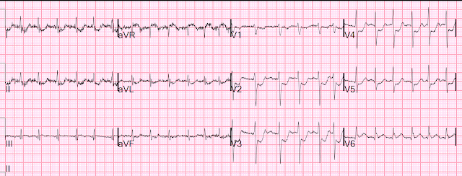

In the time you spent with Mrs. Haynes, you establish that she continues to be restless and is now complaining of chest tightness when she breaths.

## Additional assistance to complete this assessment

Referral to the topics delivered in this course will provide students with the knowledge required to promote successful completion of this assessment.

For example, the weekly learning activities to develop a plan of care will prepare students to complete the case report. Students should make sure that they read and cite all information provided and use opportunities to discuss this assessment in the weekly tutorials or virtual classrooms.

Students are also encouraged to explore the [getting started](https://lo.unisa.edu.au/course/view.php?id=27566&sectionid=611924) section for resources for writing a case study.